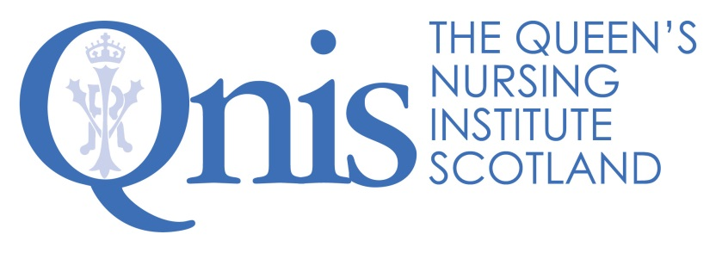
Creating connections in homeless and inclusion health
We are looking forward to seeing you on Tuesday 17th January 2017 for the first Homeless and Inclusion Network meeting specific for nurses in Scotland hosted by the Queen’s Nursing Institute Scotland on behalf of the Network.
The venue for the event is The Mews (NASUWT Offices), at 35 Young Street Lane North, Edinburgh, EH2 4JD. Please arrive around 1.45pm for tea/coffee. The event will start at 2pm and is due to finish around 4.30pm.
The programme for the afternoon is as follows:-
- Welcome – the beginning of a new network (Clare Cable, QNIS)
- Introductions (all)
- Creating Connections with patients and clients – Speakers Jayne Churchill and Jess Davidson
- Tea/Coffee Break
- Creating connections for nursing in homeless and inclusion health - Facilitated discussion
- Future Meetings (plan for 2017/18)
If you have colleagues who would like to come please ask them to email me so that I can add them to the list of attendees for the venue.

