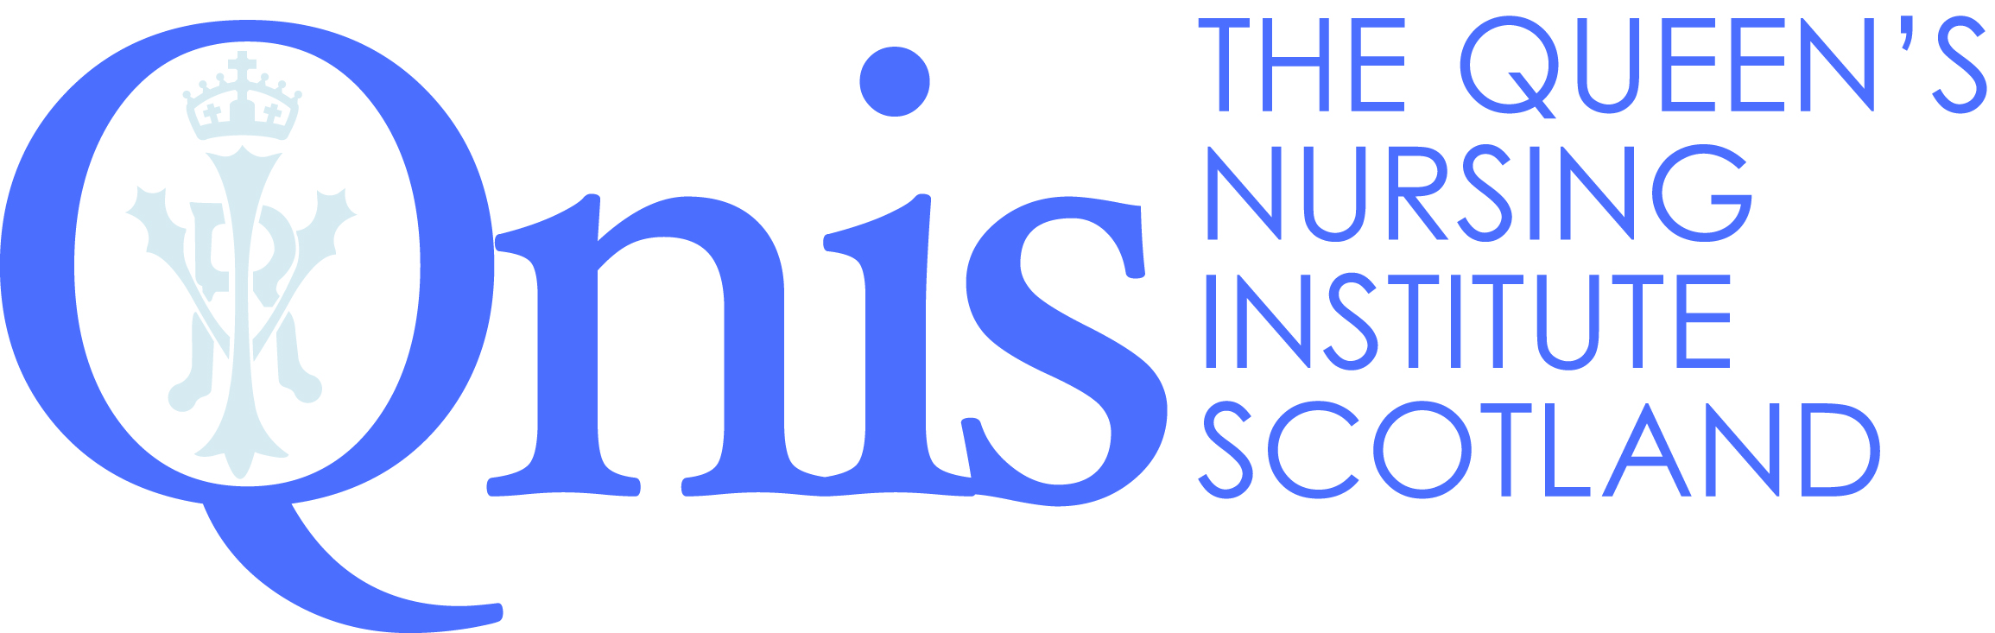
COMMUNITY NURSING

AWARD FOR LONG SERVICE

Date of application: |  | QNIS Ref No (if known):

Title | First Name | Last Name

Total number of years of employment as a nurse within the community in Scotland
Any additional years of nursing in the community elsewhere in the UK or overseas
Please note that you must have at least 21 years working in the community to qualify for a Long Service Award

Professional Qualifications
Date Completed | Name & Place of Education Institute | Qualification

Brief Employment History
Date | Position | Employer

Please continue overleaf

Address to send Award to:

Work Address OR Home Address
Name of health centre/other: | No:
No./Street: | Street:
Town: | Town:
County: | County:
Postcode: | Postcode:
Work Phone No: ( ) | Home Phone No: ( )
Work Mobile No: ( ) | Home Mobile No: ( )
Please send emails to… (please print clearly)
Email address: ________________________________________________________________________
Is this a work: or personal email:

Alternate email address:(if unable to contact you at address above)
_______________________________________________________________________
Any personal data collected through this website will be processed in accordance with the General Data Protection Regulation 2018
To verify that the information supplied on this form is correct we may contact your current employer. Please provide details below:
Name:
Position:
Working relationship
to applicant:

If you or the person nominating you would like to provide a supporting statement, please complete below:

Please return completed application to:
fiona.fitheridge@qnis.org.uk or
Fiona Fitheridge| Welfare and History Manager
31 Castle Terrace | Edinburgh | EH1 2EL
0131 229 2333 | www.qnis.org.uk

