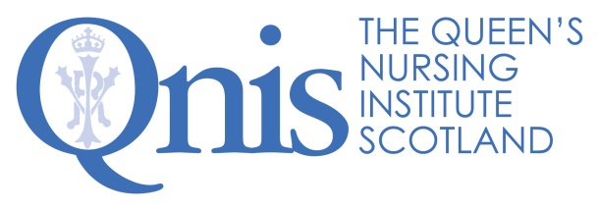
Media and External Relations Manager Excellence Profile

Team work | - Builds and maintains a great rapport with colleagues.  - Demonstrates a ‘can do/will do’ attitude and a willingness to roll up sleeves and get involved in anything that needs doing.  - Understands the challenges and benefits of working in a small team and enjoys doing so.  - Shares knowledge, information and ideas to support working as a team.  - Is enthusiastic about the role and energises those around them.  - Has the confidence to ask others for support and looks for ways to support them.  - Takes time to celebrate after working hard to achieve goals.  - Balances the urgent and important and enjoys working flexibly.  - Thrives in a dynamic and rapidly changing environment, embracing change.  - Brings a sense of fun to the office.

Relationship management | - Builds positive relationships, on the phone and in person, with our networks to enhance our reputation with stakeholders across Scotland.  - Develops effective working relationships between QNIS, key media and communications contacts and external contractors.  - Builds trust through delivering on actions agreed and exceeding the expectations of others.  - Able to lead and take part in discussions within both formal and informal settings.  - Works alongside our stakeholders to provide jointly branded output.  - Engages positively with new Queen’s Nurses, QNIS prize winners and others to develop news and web content so they feel proud to have been profiled.

Outputs and productivity | - Prioritises work, sifting the important and the urgent and constantly looking at ways to do things more effectively.  - Maintains and develops the QNIS website as a highly engaging resource for nurses, stakeholders and the public, increasing traffic to it year on year.  - Tells great stories which profile Scotland’s community nurses, suitable for a range of media, which enhance the reputation of QNIS and community nursing.  - Keeps an eye on latest updates in healthcare across media and politics and summarises it accessibly for the QNIS website and twitter.  - Brings a great blend of creativity, innovation and attention to detail to all aspects of work.  - Demonstrates agility between formats and audiences.

Technical know how | - Has content management skills to keep webpages up to date, changing regularly and highly engaging.  - Understands the nuances of Scottish politics and media and sensitivities across the UK.  - Recognises the commonalities and differences across the range of nursing roles within Scotland’s communities.  - Writes compelling news items, profiles and blogs for internal and external use.  - Is able to extract relevant points from extensive documents, and provide succinct summary.  - Presents information convincingly.  - Is able to deliver messages with impact using a range of digital and traditional media.  - Uses social media to promote a brand and provide updates building numbers of followers.  - Skilled in editing digital images for use across media.

QNIS 2020

