School Nurse Yes, Yes, Yes!

Co-production and partnership working as a tool for embedding children's rights in School Nursing service delivery and post graduate Advancing Nursing Higher Education

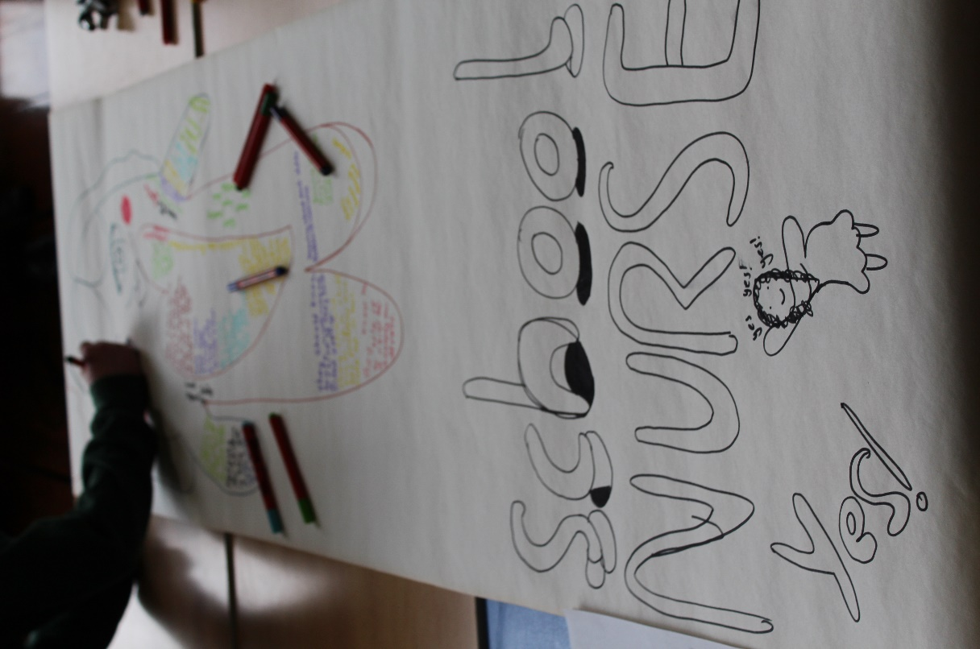

Dr. Elaine Allan - Lead Nurse School Nursing
Aberdeen City Health and Social Care Partnership

Acknowledgements:

The Imagineers

The Children’s Parliament Scotland

The Aberdeen City HSCP School Nurse Team

NHS Grampian

Aberdeen City Council

The Robert Gordon University

Background

Human rights as set out by the “United Nations Charter of the Rights of the Child” (UNCRC) aims to empower children. The charter includes the right of all children to be able to access health services to meet their needs. In addition, the charter states that children have the right to express their views in all matters affecting them, and that their views are given due accordance within the child’s age and maturity. Empowering children facilitates them to better understand their rights, and improve their confidence to engage with and influence the people and organisations that affect their lives and to hold them accountable. All children’s services need to embed this principle. This paper offers a model that could be replicated across services and agencies.

An Aberdeen City Children’s Rights Approach - The Imagineers

Early in 2016 “Imagining Aberdeen” began with 300 children from various primary and Secondary schools to imagine how Aberdeen can be a city where children are healthy, happy and safe. A smaller group of children became Imagineers capturing ideas and important messages from their schools through art and video. The Imagineers are now a group of 40 children, aged 9-13, from across the city who attend various Primary and Academy schools and connect with plans for the future. They have investigated four main themes for children: mental health, early years and families, transition to adulthood and attainment and have shared their vision with Imagineer Champions.

Imagineer Champions are key personnel from Aberdeen City, Council, NHS Grampian, RGU and Police Scotland (North East). The role of the Champion is to listen to the Imagineers, share what they have heard and take direct action so that tangible improvements are made for children across Aberdeen. Through the Imagining Aberdeen programme, the Imagineers identified mental health and wellbeing as an important issue and spoke positively about the role of the school nurse as someone they feel that children can turn to when they need support. With encouragement from Imagineer Champion, Dr Elaine Allan the Lead School Nurse for School Nursing Aberdeen City Health and Social Care Partnership (ACHSCP) /Lecturer at Robert Gordon University (RGU) and facilitated by the Children’s Parliament the Imagineers investigated what they need from their School Nurse and produced a report as follows:

Imagineers Investigate: Thinking about what we need from our School Nurse:

Dear school nurse,

Nurses should be calm, loving and kind to the pupils. It is important that you are optimistic, joyful and can always offer moral support. You should speak to children and listen. School nurses should learn more about emotions, so they can help children if they need it. You need to be at school more and you need to have time to talk.

From the Imagineers

Our experiences of school nurses: We never see them. We have a school nurse office, but the PSAs use it. If you fall over, a PSA helps. PSAs give you first aid. We get the flu jab but there are 4-5 people, and they can be different from the ones you have met before. We don’t know them.

We have been thinking about a great school nurse.

They think: Children are great. Children are clever. Children are cool. Children need my help and I can help them. Children might feel a bit left out and worried if no one is playing with them or speaking with them. If something bad happened in their life or family are fighting and arguing, children might feel worried.

They say: Don’t worry. You’ll be ok. It’ll be fine. You are amazing. Love yourself. Don’t be stressed. Don’t smoke. Eat healthy. You are amazing the way you are. Try to stay calm. You matter.

They feel: Carefree. They make pupils feel good. Excited to come to school. Happy. Sweet. Great (because they eat a healthy lunch). Loving. Joyful.

They know: Emotions. How important it is to give children time. Children are delicate. How to calm children down. About fresh food and first aid. How to treat children with kindness. They need to know about each child. How treat children well, make them healthy and not feel left out.

They do: Play with pupils. Offer moral support. You see them around school most days. If you get hurt, they help. They aren’t rude or mean. Respect pupils like a family member. Listen to you. Help you. Make the school give fresh and healthy
food. Treat you nicely. Support the school. Be kind and loving. Try their best. Help you if you feel left out. Make you happy.

Important messages from the Imagineers investigations (relevant for School Nurses’ practice)

• Children want to tell a trusted adult their worries, but they don’t want this person to tell other teachers and professionals what they have shared. There should be trusted adults to speak to in private without the worry of it being spread

• Bullying gets in the way. Adults may say that it’s just a joke and that the child that is being bullied is just overreacting and taking it too seriously. Bullying stops children going to school. Bullies need to understand the pain they put you through. Bullying and racism can stop children from being able to do their best and take part in the activities they want to.

• Sometimes adults aren't good to talk to because they always think you need help or try to make it better instead of asking how you are and talking about your feelings. Adults usually just want to fix the problem and what children might want is somebody just to listen and be there for them.

• Children need time spent on them and to be listened to. This make them feel valued.

• Make sure all children get enough to eat.

• Behaviour is communication. Adults need to understand this instead of punishing and shouting.

The report was shared and discussed with the ACHSCP school nurse team and RGU colleagues. From these discussions it was agreed that that it was important to explore how the school nursing service and RGU could embed a children’s rights approach so that their voices are heard. to improve service delivery and to educate poste registration MSc school nursing students through module co-design influenced by the children and young people.

In partnership with the Imagineers workshops were organised and supported by Aberdeen City Health and Social Care Partnership NHS Grampian, Aberdeen City Council, The Robert Gordon University and the Children’s Parliament.

AIM

The aim was for Aberdeen City HSCP School Nurses, and RGU representatives to:

- enable the participation of children and young people through a right based co-production model to improve school nurse services and design of post graduate Higher Education to better hear children and young people’s voices.

- put children and young people’s healthcare rights at the heart of our work through listening to 'representative' voices of children and young people, hearing directly what they need from school nurses and what skills they perceive school nurse post graduate students require to learn about via postgraduate Higher Education.

Three workshops took place and included:

• Introduction – we are the Imagineers and what we do
• What school nurses, student school nurses and children’s nurses should:
- do
- know
- think about children
- say
- and school nurses, student school nurses and children’s nurses should make children feel

Workshop 1: The children and young people held a facilitated workshop by the Children’s Parliament to produce their vision of:

What school nurses, student school nurses and children’s nurses should:
- do
- know
- think about children
- say
- and school nurses, student school nurses and children’s nurses should make children feel

Workshop 2: Imagineers, ACHSP School Nurses, Robert Gordon representatives, held a facilitated workshop by the Children’s Parliament

Aim: For the C&YP to share their vision and artwork form workshop 1 with the SN team and RGU representative to find out if their vision was the same as how school nurses deliver the service and are educated.

Did the Imagineers Vision match?

Emerging Matching Themes -

School nurses and school nurse students should:
Love children and their job
Know about health and wellbeing especially mental health and wellbeing, allergies, asthma.
Know that children have emotions and about how to help children deal with them
Think that-
Children are Important
Children can trust, them
Children should be respected
Know it is OK for children to feel the way they do, and will help if they are worried, and help build their confidence and keep them calm.
Be fun to be around
Show that they are confident in helping children and young people
Understand it is important to listen to children and young people
Feel it is important that they try to help Children and young people
Know it is important to keep children safe and how to do this
Know it is important that everyone knows and understands Children’s Rights

Emerging Themes for Improvement -

We need more school nurses
We sometimes don’t know we have one to go to because they are in different schools
We need to see school nurses more in school
We want to know how school nurses know about us
We want to know who you are
We want to play more with school nurses
We sometimes don’t see them in schools
We sometimes don’t see them in assembly
They don’t always give out stickers

Workshop 3

Emerging Themes

What could school nurses do to improve?

Put photo of the school nurse in school
Provide a more visible timetable on the SN room door of when the school nurse is in school
Wear NHS lanyard that says Nurse so it is easily visible and identifiable
Lobby for more school nurses
Speak about school nurses in blogs and newsletters
Use bubble time to let the teacher know that a child wants to go see the school nurse and if it is a Green issue- It can wait, or a Red issue – can’t wait
Deliver a presentation at first term assembly about the school nurse and how to make contact
Raise awareness of the school nurse and what the school nurse does
Visit classes to tell children she is there and introduce herself
Have workshops with the children and young people
Have health and wellbeing workshops
Put news in school newsletter about the school nurse
Tell children a bit about themselves and what they like to build a relationship
Have fun activities
Have more visible leaflets in schools with School Nurse name and contact on it
School nurses invited into class/school and the pupil council
Be that one person to wear funky clothes

Agreed actions

School nurses will action the above via a rolling programme using Quality Improvement Methodology and keep the children and young people informed of progress.

Some feedback from the school nurses

“I loved the positive outcomes from the Imagineers visit”.

“It was really insightful to hear their visions for the future”

“It has reminded staff how exciting the future could be and that if we work together and make small changes we can improve outcomes for all.

The artwork and outcomes of this work will go on to influence School Nurse service delivery and development in NHSG and the delivery of Higher Education within The Robert Gordon University through co-production and development of a video training resource (link below) to highlight and strengthen knowledge of C&YPs rights, and to raise awareness and understanding across more areas of society.

https://medialibrary.rgu.ac.uk/player?autostart=n&fullscreen=y&width=835&height=505&videoId=Be9G5gGF&captions=n&chapterId=0

In response, the Aberdeen City school nurse team met with the children in January 2020 to share ideas on how to improve the visibility of school nurses within schools across the city; enable children to understand the school nurse role better and how to access it.
The school nurse team listened and planned to act upon the children’s ideas, where possible, and report progress back to the Imagineer team.

We planned to publicise this work and have a “Premiere Showing” of the video with all the Imagineers present to celebrate, however COVID 19 arrived and lockdown soon followed.
Since listening to the children and hearing how important mental health and wellbeing is, all school nurses have been LIAM trained and will be utilising their skills to benefit children and young people.

The work of the children should still be celebrated and the plan going forward is to publicise their effort and enthusiasm.

In the meantime school nurses have listened are still available and children and young people can make appointments for NEAR ME confidential consultations advertised via NHSG and ACC social media and in the local press.

Finally it is important to finish with the voice of the Imagineers. Here are some of the suggestions that the Imagineers said would improve the school nurse service and help children and young people,

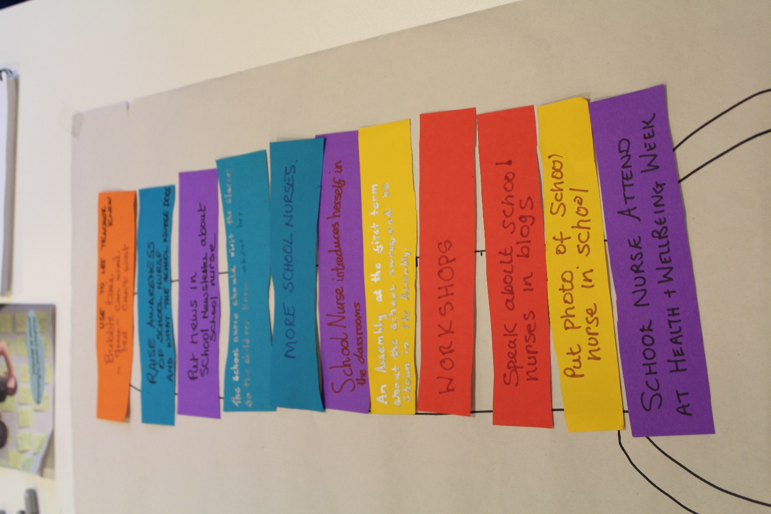

CHILDREN ARE OUR FUTURE

