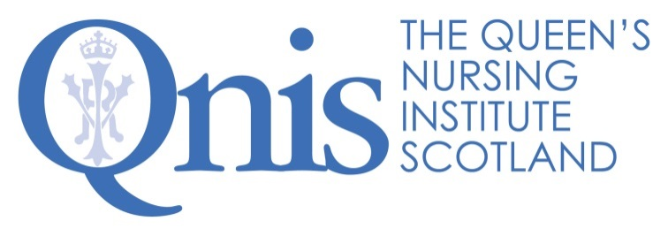

Queen’s Nurse Programme Application Form 2021
Data protection statement:
Your privacy is important to us, and we will NOT pass your details to any third party. The Queen's Nursing Institute Scotland will only use the information provided on this form if we wish to contact you to verify the information you have provided. If your application is unsuccessful your personal data will be destroyed after six months. If your application is successful your data will be kept in accordance with GDPR. For more information on your privacy rights please see our privacy policy https://www.qnis.org.uk/privacy-policy or contact comms@qnis.org.uk for a copy.
All boxes will expand as you type
- PERSONAL DETAILS
Surname
First name
Known as
Title (e.g. Mr/Mrs/Ms/Miss/Other)
NMC Registration Number
Revalidation date
Home address
Mobile telephone number
Home email address
How did you hear about the QN Programme?
EMPLOYMENT DETAILS
Current job title
Length of time in this role
Employer
Work address (full)
Work telephone number
Work email address
Nominating Nurse Executive Director (NHS staff) or equivalent executive leader within your organisation:
Name
Email address
Senior (Nurse) Manager acting as programme sponsor:
Name
Email address

PROFESSIONAL AND HIGHER EDUCATION (Undergraduate and post-graduate of 1 year’s length or more)
Year | Institution | Qualification

KEY RESPONSIBILITIES IN CURRENT POSITION list briefly
1.
2.
3.
4.

COMMUNITY NURSING EXPERIENCE – begin with position prior to current and detail your employment which demonstrates your experience in community based nursing roles
Date | Position | Key responsibilities

- IN SUPPORT OF YOUR APPLICATION – please read the excellence profile in the guidance document and give us examples from your practice of how your expertise matches the areas below. Please remember this is not a job application, we are not looking for a list of achievements, rather your ability to reflect and describe the impact of your skills and behaviours on others. Each statement begins with the question HOW?
How have you made a difference?
- changing how things are currently done
- making things better for individuals, families and communities
- helping others to make a significant impact

(no more than 3500 characters which is around 500 words)
How have you demonstrated your tenacity and resilience?
- finding your way across boundaries, around obstacles, through bureaucracy
- successfully challenging attitudes
- finding new doors to open each time one closes
- being prepared for continuous change, development and transformation

(no more than 3500 characters which is around 500 words)
How have you brought people with you?
- using your enthusiasm and persuasive nature
- creating a ground swell of support and getting others to commit and get things done
- staying connected with important others
- working with crisis as a development opportunity.

(no more than 3500 characters which is around 500 words)
How have you demonstrated your ability to reflect?
- listening deeply, seeking to understand what really matters
- approaching life reflectively, always learning
- quick to attribute success to others and not seek credit
- showing kindness for yourself and others

(no more than 3500 characters which is around 500 words)

- WHAT IS YOUR VISION for the role of Queen’s Nurses in Scotland’s communities and why would you like to be selected for this year’s cohort? Do you have a vision of what the best you can be looks like and feels like and the changes you would like to see in the community you work with?

(no more than 3500 characters which is around 500 words)

- YOUR ISSUE FOR DEVELOPMENT – please read the guidance document and tell us about the issue you have agreed with your sponsor which you will develop over the course of this programme. Please set out the nature of the issue or community need you wish to address, who will be involved, how you plan to engage those affected and what you hope might be achieved, whilst recognising that the emphasis is on co-production so that plans will emerge as you listen to the views of others.
(no more than 4000 characters which is around 550 words)

Please check your completed application before it is emailed to QNIS. All sections must be completed or the application cannot be put forward to the assessment panel.

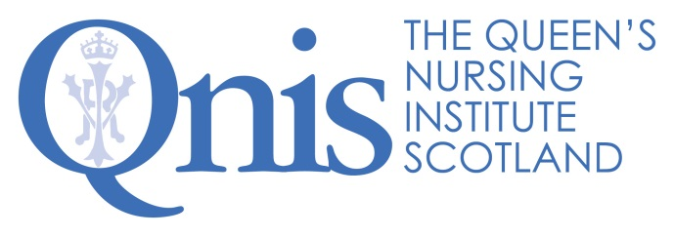
Equalities Monitoring Form
Strictly Confidential

QNIS is committed to promoting fairness and eliminating discrimination from recruitment and selection practices. We will ensure that no applicant receives less favourable treatment either directly or indirectly, on the grounds of age, race, disability, gender, marital status, religion or faith or sexual orientation.

To monitor and audit the effective delivery of this commitment, QNIS requires all applicants to provide information asked for in this monitoring form. This will only be used for this purpose, will form no part of the interview process and will be treated in strict confidence, in accordance with Article 9 of GDPR.

The form will be detached from your application form and transferred to a database to help monitor the diversity of applications we receive. This will enable us to develop appropriate policies and procedures in respect of diversity and equal opportunities.

1. Gender: Male Female

2. Date of birth:

3. Marital status: Married Single Divorced

Other (Please specify …………………………)

4. Nationality:

5. How would you describe your ethnic origin?

White |  |  |  | Black or black British
A | British |  |  | M | Caribbean
B | Irish |  |  | N | African
C | Any other white background |  |  | P | Any other black background
Mixed |  |  |  | Other ethnic groups
D | White and black Caribbean |  |  | R | Chinese?
E | White and black African |  |  | S | Other ethnic groups
F | White and Asian |  |  |  | Please specify ……………………………..
G | Other mixed background |  |  | Z | Not stated
Asian or Asian British
H | Indian
J | Pakistani
K | Bangladeshi
L | Other Asian background
 | Please specify ………………………………

6. Disability is defined by the Disability Discrimination Act as;

A physical or mental impairment, which has a substantial and long-term adverse effect on a person’s ability to carry out normal day-to-day activities. The disability could be physical, sensory or mental and must be expected to last at least 12 months.

Are you a disabled person as defined by the Disability Discrimination Act?
Yes No

7. How would you describe your religion or belief?

Christian Buddhist Hindu Jewish

Muslim Sikh None Prefer not to say

Other (please specify ……………………………………………………………………)

8. What of the following describes your sexual orientation?

Bi-sexual Gay Heterosexual Lesbian

Other Prefer not to disclose

Thank you for completing this form. Please return it with your application.

