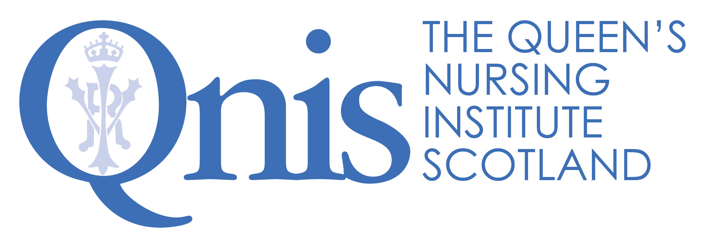

The Queen's Nursing Institute Scotland

Application for the Queen’s Nurse Programme

Guidance for Sponsors of General Practice Nurses

The organisational support form is at the end of this document and is there to ensure that nominated candidates have the commitment of their employer for their participation in the Queen’s Nurse Development Programme. In addition, we have asked for each candidate to have a sponsor. This may be the GPN Lead within the health board, another senior GPN in the area or a GP colleague. What follows is information for you as sponsor, to be read in conjunction with the main guidance document. Please get in touch if there is anything further you require.

A reminder of the benefits to employers

- A fully funded development opportunity for community based clinical leaders.
- Development of a key issue, of importance to the employer, which participants will work on with support over the nine month period.
- Participants who will develop their skills and capabilities and will also bring others with them as partners in the issue for development.
- A chance for the participants to establish a career - long identity as Queen’s Nurses, becoming part of a network of ongoing support, annual master classes and events. It is envisaged that they, in turn, will mentor others and will be seen as role models locally and nationally.
- An important opportunity to profile expert community nursing and share positive messages about contemporary nursing practice.

The Commitment
Before nominating an individual, please be aware of the time commitment necessary for their participation and from you as sponsor. In partnership with Scotland’s Gardens, the Queen’s Nursing Institute Scotland has funded the development programme: the week long (Monday-Friday) residential workshop, the two other workshops (lunchtime one day to lunchtime the next), individual coaching as well as all accommodation and travel costs.
We expect employers to release staff and give them the time to participate. If they are selected, this is nine days in total over the year, which should include travel time to all but the most remote and rural areas.
In order to make the most of the opportunity some candidates have found it helpful to negotiate some additional development time to take forward their issue. It may be helpful to think about whether it might be possible to free up some additional time to enable the candidate to explore the literature or contact others in the area under review or to set up meetings with stakeholders and listen to their ideas. This needs to be carefully discussed with you as sponsor from the outset, so expectations are managed. QNIS would be delighted if you felt able to consider whether you might support the individual taking forward this issue whether or not they were selected for the Queen’s Nurse Programme.
Nominations

Scottish Government, with NHS Education for Scotland, has made funding available to support four General Practice Nurses to join the 2018 cohort. We are therefore seeking nominations from General Practices who would like to nominate nurses who are interested. Those nominated will then apply using a written application to demonstrate their skills against the Excellence Profile and describe an issue which they would like to explore during the development programme. The most important quality is that those selected should be really enthusiastic about being put forward to be Queen’s Nurses, and willing to act as a role model for others.

Candidates being nominated as potential Queen’s Nurse candidates should meet the following criteria. They must:
- Have current registration with the NMC as a nurse, midwife or health visitor.
- Be known as a community nursing expert, and seen as a role model by their peers, probably operating at level 6/7 of the career framework.
- Demonstrate the qualities outlined in the Excellence Profile.
- Be available to attend any of the selection events to which they may be allocated (see below).
- Be available to attend the residential workshop from 5th -9th March 2018 and the two subsequent 24 hour workshops 14th/15th June 2018 and 18th/19th October 2018.
- Have the full support of a senior colleague as sponsor for the programme.
- Have a development issue in mind, agreed with their sponsor to work on during the Queen’s Nurse Development Programme.
- Have a signed commitment of support from their General Practice Employer.

Completing the application form
The individual you are nominating will need to complete the application form. Since the opportunity is an important one, we are asking people to be reflective in their applications. If they have been through the new NMC revalidation process they may find it similar. It will take significant time and thought to complete the application and we recommend that applicants allow a few weeks to complete the various sections and check them over. There are examples on the website. Please provide them with a “critical companion” to review the application before submission.
The first sections of the application require information about career and current role. The supporting information, section 2, asks applicants reflect on their practice in the light of the Excellence Profile which you will see in the guidance. The Excellence Profile describes the contemporary Queen’s Nurse and the qualities which we will be looking to develop further over the course of the development programme. We are looking for examples of how their expertise already matches the areas described in the profile, recognising that this is a development journey. The panel is looking for self-awareness; the ability to reflect on how behaviours have had an impact on patients and colleagues. Please support applicants in their reflection and encourage them to think about HOW their actions have made a difference and what they have learned.

The issue for development
During the programme every candidate will be expected to work on an issue for development which makes a difference to their community, based on a need which they have identified with you as their sponsor. The work is to be co-produced with those affected, so plans do not need to be set in stone at this stage and will emerge in conversation with others. It is expected that the issue is taken forward as an integral part of their core role in negotiation with you as sponsor. This needs to be carefully discussed from the outset.

What happens next?

Closing date for written applications from GPNs (including organisational support forms) | 11th December 2017
Candidates informed and invited to selection events if short listed | 21st December 2017
Regional selection events | January 2018

You will also be informed of the decision by email, for the candidates you have nominated. Similarly, after the selection events, you will be informed of the outcome either way. Candidates who come to the selection events are all given feedback from the day and you may wish to take time to review this with them.

Thank you in advance for your commitment to the programme. It would not be possible without your vision and support

The Queen's Nursing Institute Scotland

Application for the Queen’s Nurse Programme

SPONSOR STATEMENT

Name of Applicant

Health Board GPN Lead or other senior collegue

Name

Job title

Postal address

Postcode

Telephone number |  | Mobile
Email |  | Fax

Please tick here if you would like to receive a quarterly e-newsletter about the work of QNIS

Data protection statement:
Your privacy is important to us, and we will NOT pass your details to any third party. The Queen's Nursing Institute Scotland will only use the information provided on this form if we wish to contact you to verify the information you have provided.

How long have you known the applicant? Please tick
Less than 3 months | 3-6 months | 6 months - 1 year | 1-2 years | 2-5 years
In what capacity do you know the applicant?

Please outline in what ways the candidate is seen as a community nursing expert and a role model by their peers. (all boxes will expand as you type)

A Queen’s Nurse is described in the excellence profile below.
Please comment on how the following statements reflect the applicant’s professional skills.
It would be helpful if you could provide examples to support your statements

Queens Nurses…. Inspiring Others by making a difference:
They find opportunities (or circumstances find them) for changing how things are currently done, recognising how things should and could be, making things better for individuals, families and communities and/or helping others to make a significant impact.

Please give examples from your experience of the applicant’s practice (250 words)

Queens Nurses…. Inspiring Others with tenacity and resilience:
They find their way across boundaries, around obstacles, through bureaucracy and successfully challenge “but we don’t have control over that” or “that will never work here” attitudes. They just keep bouncing back, finding new doors to open each time one closes.

Please give examples from your experience of the applicant’s practice (250 words)

Queens Nurses…. Inspiring Others by bringing people with them:
Through “coming from the heart”, their enthusiasm and persuasive nature, they create a ground swell of support and recognition that has “carried the day”, getting others to commit and get things done.

Please give examples from your experience of the applicant’s practice (250 words)

Queens Nurses…. Inspiring Others with humility and reflection:
They listen deeply, seeking to understand what really matters. They approach life reflectively, always learning and are kind to themselves. They will sometimes be surprised by personal recognition for their achievements, and are quick to attribute success to the contribution of others.

Please give examples from your experience of the applicant’s practice (250 words)

Development project – please comment on the importance of the agreed issue to be explored within the development project to the local community and your commitment as project sponsor.

Supporting statement: Please use this space to provide us with any additional comments you would like to make in support of this application

Senior (Nurse) Manager – Organisational Sponsor

I have talked with the candidate about this potential issue for development and agree the work is a priority for this community and I will actively support the work.

Signature of GPN Lead (Health Board) or other senior colleague:

Nomination by Senior GP Partner or Practice Manager

I am delighted to nominate [insert name of candidate] for selection as a new Queen’s Nurse. We commit to enabling her/him to attend the residential and follow up workshops and to supporting the development issue which she/he will work on during the nine month programme.

Name of Senior Partner or Practice Manager:

Signature:

