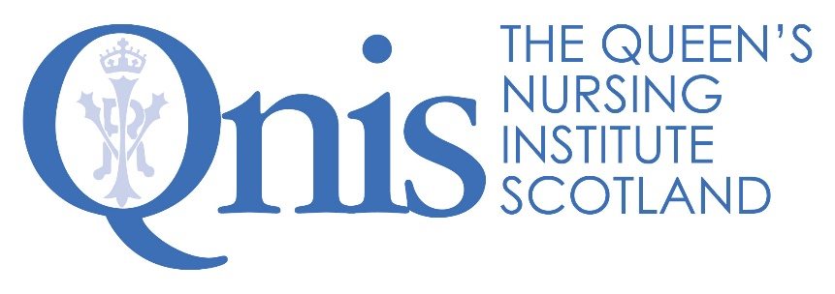

Scottish supplement to: Safeguarding practice for those at risk of financial abuse from scamming: a workbook for community nurses and healthcare professionals.

This excellent resource, co-authored in 2018 by Prof Keith Brown and Dr Sally Lee of Bournemouth University, supported by the Burdett Trust for Nursing, was the foundation for a multiagency QNIS event in Edinburgh during October 2018. The presentations and other information from that seminar are available in the ‘What we do’ section of the QNIS website: www.qnis.org.uk
The substance of the workbook is entirely relevant in Scotland. However, some UK legislation applies north of the border, but not all. The publication also lists a wide range of national/international references and UK organisations. What follows are details of Scottish specific legislation, information and sources of support that will make this workbook even more useful to community nurses working in Scotland.

Key Scottish Legislation
Adults with Incapacity (Scotland) Act 2000: https://www.legislation.gov.uk/asp/2000/4/pdfs/asp_20000004_en.pdf
Mental Health (Care and Treatment) (Scotland) Act 2003: https://www.legislation.gov.uk/asp/2003/13/pdfs/asp_20030013_en.pdf
Adult Support and Protection (Scotland) Act 2007: https://www.legislation.gov.uk/asp/2007/10/pdfs/asp_20070010_en.pdf

Third Sector Organisations in Scotland
Citizens Advice Scotland: https://www.citizensadvice.org.uk/scotland/ This includes the Consumer Helpline: 03454 04 05 06 (or Textphone: 18001 03454 04 05 06).
Action on Elder Abuse Scotland: https://www.elderabuse.org.uk/in-scotland. They also can be reached via their helpline: 080 8808 8141.
Age Scotland: https://www.ageuk.org.uk/scotland/ Their helpline number is: 0800 12 44 222
Society of Chief Officers of Trading Standards Scotland (SCOTSS): https://scotss.org/
Public Sector Bodies in Scotland
Local Authorities in Scotland are required by law to provide a multidisciplinary service to support and protect vulnerable adults. This almost always involves social work, social care and the regional NHS, as well as other partners.
Adult Protection Policy Team (Scottish Government): AdultSupportProtection@gov.scot. Here is the webpage with further information: https://www2.gov.scot/Topics/Health/Support-Social-Care/Adult-Support-Protection/Resources
Trading Standards Scotland (Managed by the Convention of Scottish Local Authorities (COSLA): http://www.tsscot.co.uk/ This includes the ‘Report a Loan Shark’ service: http://www.tsscot.co.uk/report or 0800 074 0878, as well as advice/assistance on scam calling: http://www.tsscot.co.uk/campaigns/blocking-scam-calls
Police Scotland – Call 111 to report to a non-emergency suspected crime. To report fraud, scams or financial abuse, here is the key link: http://www.scotland.police.uk/keep-safe/246633/246663/
Office of the Public Guardian – for information and assistance with Power of Attorney, Guardianship Orders and other means of investigating and resolving financial matters involving ‘incapable’ adults: http://www.publicguardian-scotland.gov.uk/ The contact phone numbers and e-addresses are here: http://www.publicguardian-scotland.gov.uk/general/contact-us
Mental Welfare Commission of Scotland: https://www.mwcscot.org.uk/get-help/common-conditions/ To contact them for advice: 0131 3331877 or enquiries@mwcscot.org.uk

Prepared by the Queen’s Nursing Institute Scotland (QNIS), October 2018

