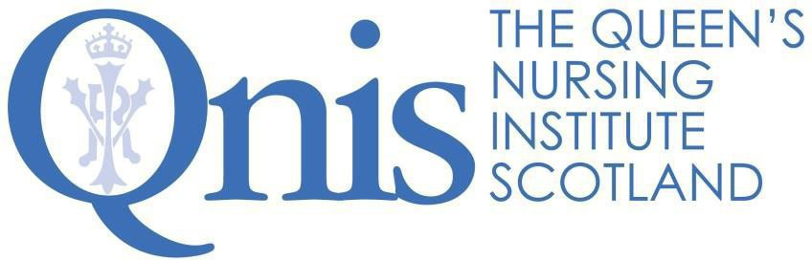

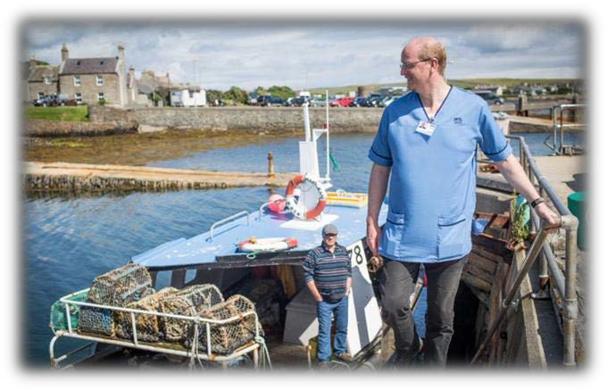
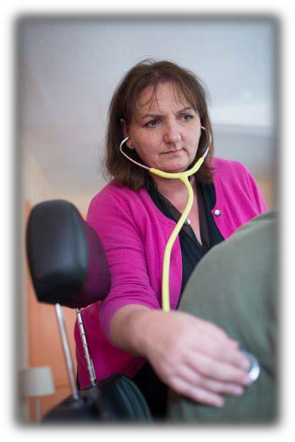
The Queen’s Nurse
Learning Disability Programme Guidance for Applicants

Promoting excellence in community nursing to improve the health and wellbeing of the people of Scotland

Contents
About QNIS 3
What is a Queen’s Nurse? 4
Why become a Queen’s Nurse? 5
The opportunities and benefits of becoming a Queen’s Nurse 6
The Queen’s Nurse development programme 7
Being nominated by your Executive Nurse Director 8
Completing the application form 9
The organisational support form 10
Next steps: the assessment and selection process 10
Summary 11
Appendix 1: The framework for person centred practice 12
Appendix 2: The residential workshop 13

About QNIS

The Queen’s Nursing Institute Scotland (QNIS) is a charitable organisation (SC005751) which exists to promote excellence in community nursing to improve the health and wellbeing of the people of Scotland. In 2019 we are celebrating 130 years of doing just that.

And we do this through:

- CONNECTING people who share a passion for high quality nursing in the community,
- EQUIPPING nurses with the education, skills and confidence they need to help people achieve better health and wellbeing and
- CHAMPIONING nurses’ roles as advocates for quality health and care.

In 2017 The Institute reintroduced the Queen’s Nurse (QN) title to Scotland. You may have read about this on our website. The title is awarded to clinical leaders who can demonstrate their impact as expert practitioners; as nurses, midwives or health visitors.
We are building on a long history of developing Queen’s Nurses for Scotland. Queen Victoria’s Jubilee Institute for Nurses first started training Queen’s Nurses at Castle Terrace in Edinburgh in 1889. Training stopped in1968 and we have a proud tradition and a clear set of values as a foundation for contemporary community nursing excellence.
In 2019, as part of the celebration of 100 years of learning disability nursing, the Burdett Trust for Nursing awarded QNIS a grant to develop an additional eight leaning disability leaders in 2020. This is a great opportunity and we are delighted to be inviting applications for this bespoke programme. The additional benefit is that the group will work on a shared issue for development to amplify their shared impact.

What is a Queen’s Nurse?

Queen’s Nurses were the first nationally trained community nurses. The training developed over the years and most Queen’s Nurses who trained after WWII were already registered nurses, midwives and health visitors, before coming to do their Queen’s training, and to develop their skills in district nursing.

Today, Queen’s Nurses undertake a huge range of community nursing roles. Our contemporary Queen’s Nurses currently represent criminal justice nursing, general practice nursing, community mental health nursing, school nursing, health visiting, community midwifery, district nursing and parish nursing as well as learning disability nursing.

“The purpose of the Queen’s Nurse programme is to enable nurses who work in Scotland’s communities to be the very best they can be.”

What does a Queen’s Nurse look like? We have tried to describe this in an

‘Excellence Profile’.

Queen's Nurses…. Inspiring Others by making a difference:
They find opportunities (or circumstances find them) for changing how things are currently done, recognising how things should and could be, making things better for individuals, families and communities and/or helping others to make a significant impact.
Queen's Nurses…. Inspiring Others with tenacity and resilience:
They find their way across boundaries, around obstacles, through bureaucracy and successfully challenge “but we don’t have control over that” or “that will never work here” attitudes. They just keep bouncing back, finding new doors to open each time one closes.
Queen's Nurses…. Inspiring Others by bringing people with them:
Through “coming from the heart”, their enthusiasm and persuasive nature, they create a ground swell of support and recognition that has “carried the day”, getting others to commit and get things done.
Queen's Nurses…. Inspiring Others with humility and reflection:
They listen deeply, seeking to understand what really matters. They approach life reflectively, always learning and are kind to themselves. They will sometimes be surprised by personal recognition for their achievements, and are quick to attribute success to the contribution of others.

Why become a Queen’s Nurse?

We know that caring for people in their own homes or in a community setting is fundamentally different from working within a hospital. Community practice requires enhanced skills and expertise and it is important to profile and celebrate this. The Queen’s Nurse title exists to recognise excellent nursing practitioners who really make a difference in their communities.

Our aim is that the Queen’s Nurse title will make a difference at a range of levels. To:
The Queen’s Nurses themselves | Queen’s Nurses are able to demonstrate exemplary practice as described in the Excellence Profile. Queen’s Nurses are able to join a supported network of others and become a social movement for positive change to the health and wellbeing of Scotland’s communities.
Individuals, families, communities | There is clear evidence of practice and service development as a result of participants’ involvement in the programme. Individuals, families and communities experience exemplary, high quality care.
Population of Scotland | Queen’s Nurses are seen to be actively involved in improving health and wellbeing.
Employers | The programme will enable the development of service leaders who inspire others; the recognition of excellence within their areas; and increased profile of high-quality work, from external stakeholders linked to key policy drivers.
QNIS | The Institute is able to fulfil its purpose to promote excellence in community nursing, to enhance the health and wellbeing of the people of Scotland and to enable nurses to be the very best they can be.
National policy | By profiling the work of the Queen’s Nurses across community nursing roles policy makers are enabled to demonstrate and clearly articulate the impact of community nursing roles.
The Nursing Profession | The programme will provide role models for excellent community nursing practice, showcasing and inspiring others towards a career in community nursing.

The opportunities and benefits of becoming a Queen’s Nurse

  - You will have the opportunity to undertake a fully funded, contemporary and inspiring development programme.
  - You will be entitled to use the words ‘Queen’s Nurse’ or the letters QN after your name.
  - You will be presented with your certificate and badge at an award ceremony hosted by the Institute.
  - You will undertake free and bespoke learning opportunities every year, so you are able to continue to demonstrate your impact as a practice and service developer.
  - You will become part of an extraordinary network of others, both in your own cohort and those who have been part of the programme before and after you.

The expectations of the Queen’s Nurse

  - You will continue to engage with the Queen’s Nursing Institute Scotland and act as an ambassador for community nursing. This may involve having others shadowing you or talking about your work at meetings or events.
  - You will be profiled in your professional role on the QNIS website and the wider media so that a general audience can see what excellent community nursing looks like today.
  - You will continue to demonstrate the professional and personal qualities that gained you the title of Queen’s Nurse.
  - You will continue to develop your own practice through deep reflection and to act as a role model for others.
  - You will maintain your registration with the NMC and if your registration ceases you will no longer be able to use the Queen’s Nurse title.
  - You will renew your QN title each year by completing the annual survey.

The Queen’s Nurse development programme

The programme consists of a five-day residential workshop, monthly coaching and further workshops.

The five-day workshop

The residential phase of the development programme takes place soon after the programme begins. This will take place over five days (Monday lunchtime finishing after lunch on Friday) 1st – 5th June 2020 at Balbirnie House in Fife.
The content of the workshop is underpinned by the Framework for Person Centred Practice see Appendix 1 and a draft programme for the week can be found in Appendix 2.

Further workshops

There are three further workshops across the remaining 17 months of the programme. These will be in September 2020, February 2021 and October 2021. The dates will be up on the QNIS website in January 2020. The workshops are an essential part of the course and if particular dates would be problematic please check with Amanda at QNIS before applying.

Individual coaching and support

Each candidate will be supported by individual coaching. Following an initial face to face meeting with the coach at the five-day workshop, the coaching sessions are 45 minutes monthly by telephone. Additional support will be provided by the virtual community of Queen's Nurses; through a closed Facebook group and a cohort WhatsApp group. In addition, each candidate is required to have the support of a manager to act as sponsor for their development project.

The issue for development

During the programme candidates will be expected to work on an issue for development with the rest of the group. The Burdett Trust for Nursing was particularly concerned that little attention had been given to preventing or supporting people with learning disability around the criminal justice system. Therefore, participants will be working on an issue together to be scoped and co-produced with those affected, so plans will emerge in partnership with others.

It is not a requirement that participants have experience or expertise in forensic nursing, but rather an interest in working on a shared endeavour to prevent or support PWLD who may find themselves in the criminal justice system. This would need to be agreed with your line manager/sponsor as being of benefit to your service. It may be helpful to protect some additional time to enable you to engage with this piece of work. This needs to be carefully discussed with your sponsor from the outset, so expectations are managed.

Costs

Thanks to a grant from the Burdett Trust for Nursing the programme is fully funded: the five day (Monday-Friday) residential workshop, the three other workshops, individual coaching as well as all accommodation and travel costs. We expect employers to fund the time for candidates to participate.

Being nominated by your Executive (Nurse) Director or CEO

Given that there are only eight places each year, we are working with the Executive Nurse Directors in NHS Scotland and equivalent executive leaders from the third and independent sector to nominate candidates. Those nominated will then apply using a written application to demonstrate their skills against the Excellence Profile and describe an issue which they would like to explore during the development programme.

Executive Nurse Directors (for third and independent sectors, the most senior member of your organisation) have been asked to work with their senior team to identify candidates to put forward for selection. The most important quality is that those selected should be enthusiastic about being put forward to be Queen’s Nurses and committed to making a difference for their community. We are also looking for those who have an interest in the shared issue for development.

Candidates being nominated as potential Queen’s Nurse candidates should meet the following criteria. They must:
- Have current registration with the NMC as a learning disability nurse.
- Spend the majority of their professional time in the community.
- Be known as a clinical expert and seen as a role model by their peers.
- Demonstrate the qualities outlined in the Excellence Profile .
- Be available to attend a selection event (see below).
- Be available to attend the residential workshop from 1st – 5th June 2020 and the three subsequent workshops in September 2020, February 2021 and October 2021.
- Have the full support of a manager as sponsor within their organisation.
- Be committed to working actively as part of a group sharing the responsibility for the issue for development.
- Have a signed commitment of support from the Executive Nurse Director
or equivalent.

Completing the application form

This is an opportunity for you to take your career to a new, exciting level and be recognised as a clinical expert in your area. Once you have been nominated by your Executive Nurse Director, or equivalent executive leader for third sector or independent employers, you will need to complete the application form. Since the opportunity is an important one, we are asking people to be reflective in their applications. If you have been through the new NMC revalidation process you will have material which you can draw on. It will take significant time and thought to complete the application and we recommend that you allow yourself a few weeks to complete the various sections and check them over. Please allow time for a “critical companion” to review your application before you submit it. There are examples of completed applications on the website, which you might find useful. They are actual applications from recent years and we have not been able to fully disguise the identities of those who wrote them. Please treat the information with sensitivity.

The first sections of the application require information about your career and current role. The supporting information, section 2, asks that you reflect on your practice in the light of the Excellence Profile which you will have seen on page 4. The Excellence Profile describes the contemporary Queen’s Nurse and the qualities which we will be looking to develop further over the course of the development programme. We are looking for examples from your practice of how your expertise already matches the areas described in the profile, recognising that this is a development journey.
Please remember this is not a job application, we are looking to hear your voice and for evidence of self-awareness; your ability to reflect on how your role and behaviours have had an impact on patients and colleagues. We understand that it feels uncomfortable to ‘blow your own trumpet’ but the application asks you to identify your strengths and be honest about the feedback you have had from others and what you have learned as you have developed over your career.
Section 3 asks you to describe your vision for the role of the contemporary Queen’s Nurses in Scotland’s communities and why you would like to be selected. In your own words, please describe what this opportunity means to you and why you would like to be considered. Do you have a vision of what the best you can be looks like?
You will also need to demonstrate an interest in getting involved in a shared piece of work with a criminal justice focus. In section 4 of the application please set out:
  - any ideas you have around issues to be addressed
  - what you bring to a team
  - how you might to engage those affected, and
  - what you hope might be achieved.

The organisational support form

This additional form is to be completed by your manager who agrees to act as sponsor during your development programme. This is whoever has line management responsibility for your team.
Your sponsor will support you as you work on the shared issue for development, agreeing the work as a priority for your organisation and community, and supporting you as you scope and develop the initiative.
This form needs to be counter signed by your Executive Nurse Director in NHS Boards or an equivalent executive leader for third sector and other independent employers.

Next steps: the assessment and selection process

Once you have submitted your application, it will be assessed by a panel who will meet in February to decide a shortlist of candidates. Invitations to a selection day for those who are on the shortlist will be sent by close of business, Monday 9th March 2020.
The selection day has been carefully designed to be relaxed, informal and interactive. From your written application forms we will have robust information about your experience, expertise and your proposed project, so the focus of the selection days will be on assessing your communication skills. Please ensure that you are available on 24 April 2020 to attend the selection day in Edinburgh.

We hope that whatever the outcome, you will enjoy the selection day and that even if you are not selected that the process of reflection in completing the application will have been affirming and useful. Please be aware that as well as personal qualities, we are looking to profile people from across the regions of Scotland.
All candidates will be given written feedback from the application and assessment process which can be used for appraisal and revalidation.

Summary

Please answer each question on the application form clearly and completely. Full answers are required to enable the panel to assess whether you have the qualities to be a new Queen’s Nurse.

Please ensure that you include an organisational support form with your application which needs to be completed by your sponsor and countersigned at executive level.

Applications received after the closing date of Monday 27th January at midday, will not be considered.

Please ensure that you are available on all the following dates:

- Selection event 24th April 2020, Edinburgh
- Residential workshop from 1st – 5th June 2020
- Follow up workshops September 2020, February 2021 and October 2021.
Please get in touch if you have any further questions. Tel: 0131 229 2333
Email: amanda.regan@qnis.org.uk

“This is a great opportunity to unleash your potential, and to join a movement of nurses committed to making a difference in Scotland’s communities.”
Clare Cable, QNIS Chief Executive and Nurse Director

Appendix 1: The framework for person centred practice

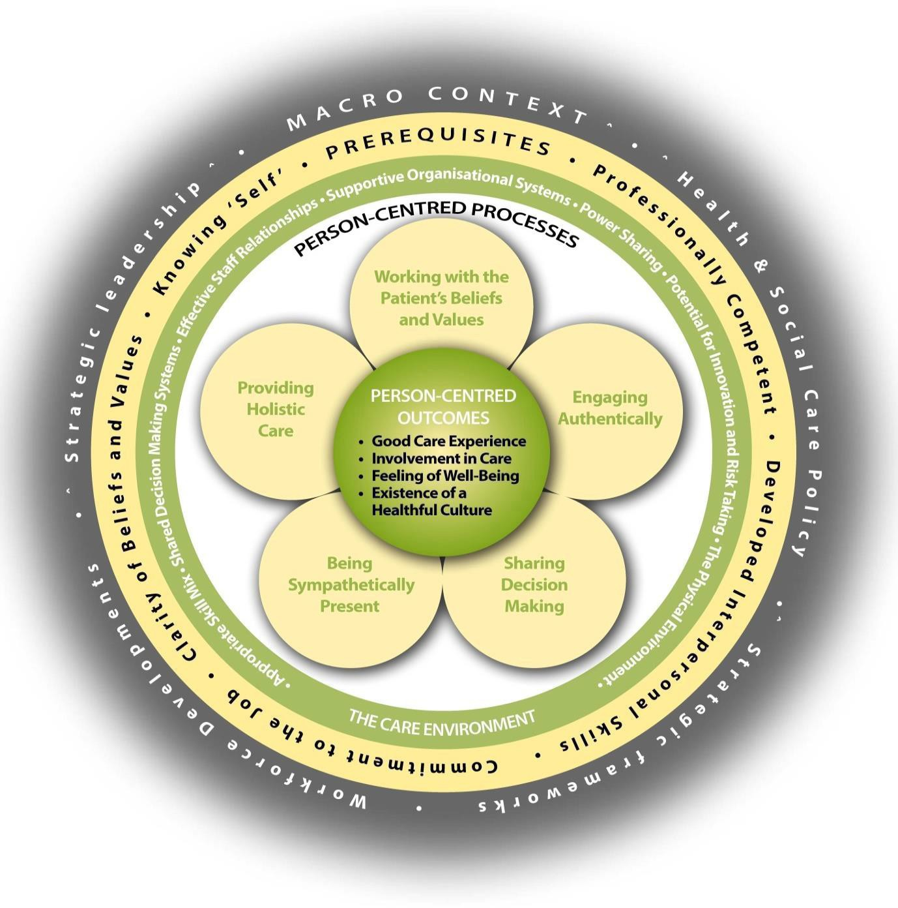

Brendan McCormack, Tanya McCance (2016), Person-centred Nursing: Theory and Practice, Wiley-Blackwell

Appendix 2: The residential workshop

A five day journey of discovery – outline programme

 | Excellence profile | Theme | Master class content
Monday | Queens Nurses…. Inspiring Others with humility and reflection | Reflecting | Personal values  Critical reflection
Tuesday | Queens Nurses…. Inspiring Others with tenacity and resilience | Enabling | Self as a leader  Personal resilience  Theory U
Wednesday | Queens Nurses…. Inspiring Others by making a difference | Presencing | Person-centred culture  Making change happen  Engagement and belonging
Thursday | Queens Nurses…. Inspiring Others by bringing people with them | Partnering | Momentum for change  Listening and observing  Creating connections  Building networks
Friday | Overview | Reflecting  Enabling  Presencing  Partnering | Participatory evaluation  Planning the journey,  Reflecting on the learning from the week.

