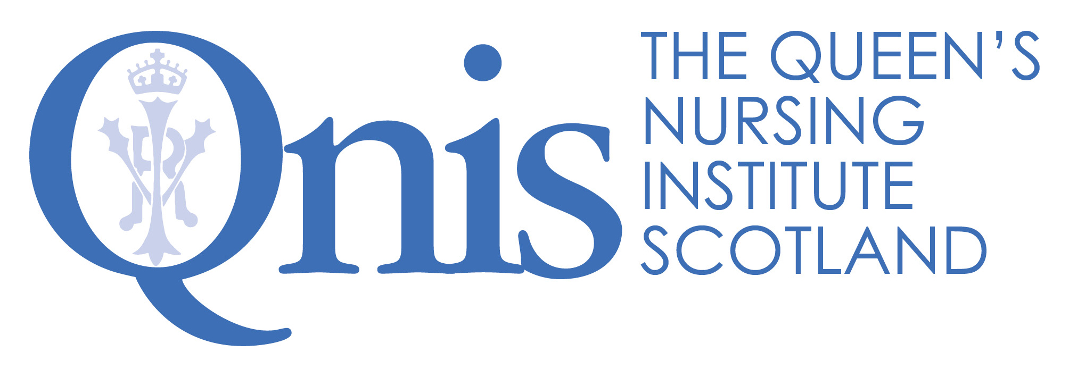

The Queen's Nursing Institute Scotland

Application for the Queen’s Nurse Programme

Guidance for Sponsors

The organisational support form is at the end of this document and is there to ensure that nominated candidates have the commitment of line managers and executive directors, or equivalent, for their participation in the Queen’s Nurse Development Programme. What follows is information for you as a manager, to be read in conjunction with the main guidance document. Please get in touch if there is anything further you require.

A reminder of the benefits to employers

- A unique development opportunity for community based clinical leaders.
- Clinical leaders who will develop their skills and capabilities and will also bring others with them as partners in the issue for development.
- A chance for the clinical leaders to establish a career long identity as Queen’s Nurses, becoming part of a network of ongoing support, annual master classes and events. It is envisaged that they, in turn, will mentor others and will be seen as role models locally and nationally.
- An important opportunity to profile expert learning disability practitioners and share positive messages about contemporary practice.
- Development of an issue with a criminal justice theme, of importance to the community, which participants will work on together with support over the programme.

The Commitment
Before nominating an individual, please be aware of the time commitment necessary for their participation and from you as sponsor. In partnership with Burdett Trust for Nursing, the Queen’s Nursing Institute Scotland has funded the development programme: the week long (Monday-Friday) residential workshop, the three other workshops, individual coaching as well as all accommodation and travel costs.
We expect employers to release staff and give them the time to participate. If they are selected, this is fourteen days in total over eighteen months, which should include travel time to all but the most remote and rural areas.
In order to make the most of the opportunity some candidates have found it helpful to negotiate some additional development time to take forward their issue. It may be helpful to think about whether it might be possible to free up some time to enable the candidate to explore the literature or contact others in the area under review, or to set up meetings with stakeholders and listen to their views. This needs to be carefully discussed with you as sponsor from the outset, so expectations are managed.
Nominations

There are eight places on this bespoke learning disability programme, we are working with the Executive Nurse Directors in NHS Scotland and leaders from the third and independent sector to nominate candidates. Those nominated will then apply using a written application to demonstrate their skills against the Excellence Profile and describe the issue which they would like to explore during the development programme.

Executive Nurse Directors have been asked to identify candidates from each NHS Board to put forward for selection. Third and independent sector organisations have also been asked to nominate. The most important quality is that those selected should be really enthusiastic about being put forward to be Queen’s Nurses, and that you as an employer are delighted to be nominating the individual as an ambassador for their specialty and your organisation. We are looking to profile the work of clinical experts across the length and breadth of Scotland working in a range of settings. There will be twice as many nominations as places available, so we would very much appreciate your additional support for those who are unsuccessful.

Individuals being nominated as potential Queen’s Nurse candidates should meet the following criteria. They must:
- Have current registration with the NMC as a nurse, midwife or health visitor.
- Spend the majority of their professional time in the community.
- Be known as a clinical expert, and seen as a role model by their peers.
- Demonstrate the qualities outlined in the Excellence Profile.
- Be available to attend a selection event (see below).
- Be available to attend the residential workshop from 1st- 5th June 2020 and the three further workshops in September 2020, February 2021 and October 2021.
- Have the full support of their manager as sponsor within their organisation.
- Have an interest in working on a shared issue with a criminal justice theme during the Queen’s Nurse Development Programme.
- Have a signed commitment of support from the Executive Nurse Director or other executive leader.

Please send name, job title and work email address of your nomination to QNIS by midday Monday 13th January 2020.

Completing the application form
Once you have nominated the candidate, they will need to complete the application form. Since the opportunity is an important one, we are asking people to be reflective in their applications. If they have been through the new NMC revalidation process they may find it similar. It will take significant time and thought to complete the application and we recommend that applicants allow a few weeks to complete the various sections and check them over. There are examples on the website to help. It may be useful to have a “critical companion” to review the application before submission. All the previous Queen’s Nurses have offered their support and their email addresses are available.
The first sections of the application require information about career and current role. The supporting information, section 2, asks applicants to reflect on their practice in the light of the Excellence Profile which you will see in the guidance. The Excellence Profile describes the contemporary Queen’s Nurse and the qualities which we will be looking to develop further over the course of the development programme. We are looking for examples of how their expertise already matches the areas described in the profile, recognising that this is a development journey. The panel is looking for self-awareness; the ability to reflect on how behaviours have had an impact on patients and colleagues. Please support applicants in their reflection and encourage them to think about HOW their actions have made a difference and what they have learned.

The shared issue for development
During the programme the candidates will be expected to work on a shared issue for development which has a criminal justice focus, based on a need which they jointly identify as a group. The work is to be co-produced with those affected, so plans do not need to be set in stone at this stage and will emerge in collaboration with others. It is expected that the issue is taken forward as an integral part of their core role in negotiation with you as sponsor. This needs to be carefully discussed from the outset.

What happens next?

Boards requested to submit nominations to QNIS | Noon 13th January 2020
Closing date for written applications from nominees (including organisational support forms) | Midday 27th January 2020
Candidates informed and invited to selection events if short listed | Invitations sent before close of business 9th March 2020
Selection event | 24th April 2020

Application forms including your organisational support form need to be received at QNIS by midday 27th January 2020. If candidates are chosen to go forward to the selection events, they will be informed by the close of business on 9th March 2020 and you will also be informed of the decision by email, for the candidates you have nominated. Similarly, after the selection events, you will be informed of the outcome either way. Candidates who come to the selection events are all given feedback from the day and you may wish to take time to review this with them.
Thank you in advance for your commitment to the programme. It would not be possible without your vision and support

The Queen's Nursing Institute Scotland

Application for the Queen’s Nurse Programme

MANAGER STATEMENT

Name of Applicant

Manager (Organisational Sponsor)

Name

Job title

Postal address

Postcode

Telephone number |  | Mobile
Email |  | Fax

Please tick here if you would like to receive a quarterly e-newsletter about the work of QNIS
You can unsubscribe at any time by contacting comms@qnis.org.uk

Data protection statement:
Your privacy is important to us, and we will NOT pass your details to any third party. The Queen's Nursing Institute Scotland will only use the information provided on this form if we wish to contact you to verify the information you have provided. If the candidate you are sponsoring is unsuccessful your personal data will be destroyed after six months. If the candidate you are sponsoring is successful your data will be kept in accordance with GDPR. For more information on your privacy rights please see our privacy policy https://www.qnis.org.uk/privacy-policy or contact comms@qnis.org.uk for a copy.

How long have you known the applicant? Please tick
Less than 3 months | 3-6 months | 6 months - 1 year | 1-2 years | 2-5 years
In what capacity do you know the applicant?

Please outline in what ways the candidate is seen as a community nursing expert and a role model by their peers. (all boxes will expand as you type)

A Queen’s Nurse is described in the excellence profile below.
Please comment on how the following statements reflect the applicant’s professional skills.
It would be helpful if you could provide examples to support your statements

Queen’s Nurses…. Inspiring Others by making a difference:
They find opportunities (or circumstances find them) for changing how things are currently done, recognising how things should and could be, making things better for individuals, families and communities and/or helping others to make a significant impact.

Please give examples from your experience of the applicant’s practice (250 words)

Queen’s Nurses…. Inspiring Others with tenacity and resilience:
They find their way across boundaries, around obstacles, through bureaucracy and successfully challenge “but we don’t have control over that” or “that will never work here” attitudes. They just keep bouncing back, finding new doors to open each time one closes.

Please give examples from your experience of the applicant’s practice (250 words)

Queen’s Nurses…. Inspiring Others by bringing people with them:
Through “coming from the heart”, their enthusiasm and persuasive nature, they create a ground swell of support and recognition that has “carried the day”, getting others to commit and get things done.

Please give examples from your experience of the applicant’s practice (250 words)

Queen’s Nurses…. Inspiring Others with humility and reflection:
They listen deeply, seeking to understand what really matters. They approach life reflectively, always learning and are kind to themselves. They will sometimes be surprised by personal recognition for their achievements, and are quick to attribute success to the contribution of others.

Please give examples from your experience of the applicant’s practice (250 words)

Issue for Development: please confirm that you would be happy to support this candidate in the co-production of a piece of work with a community justice theme which has resonance for your service.

Supporting statement: Please use this space to provide us with any additional comments you would like to make in support of this application

Manager – Organisational Sponsor

I will support the candidate to explore the shared issue for development with a community justice focus and I will enable their active participation in co-producing this piece of work.

Signature of Manager:

Nomination by Executive Nurse Director (or equivalent)

I am delighted to nominate [insert name of candidate] for selection as a Queen’s Nurse. We commit to enabling her/him to attend the residential and follow up workshops and to supporting the development work which she/he will undertake during the nine-month programme.

Name of Executive Nurse Director (or equivalent):

Signature:

