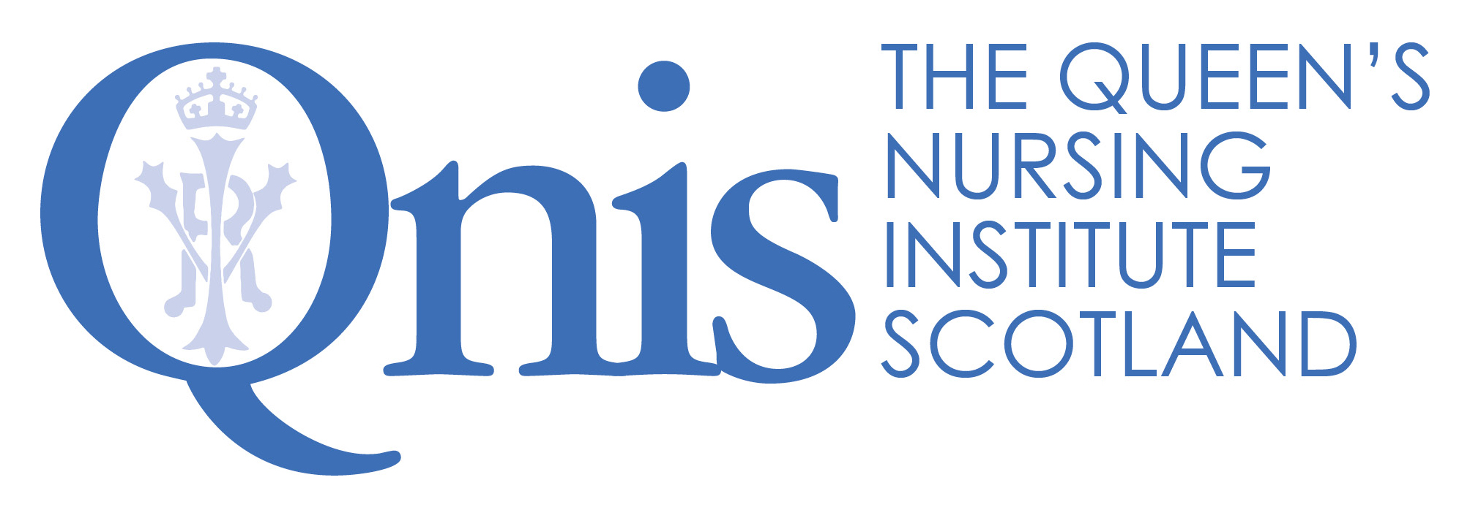

The Queen's Nursing Institute Scotland

Application for the Queen’s Nurse Programme

Guidance for Sponsors of General Practice Nurses

The organisational support form is at the end of this document and is there to ensure that nominated candidates have the commitment of their employer for their participation in the Queen’s Nurse Development Programme. In addition, we have asked for each candidate to have a sponsor. This may be the GPN Lead within the health board, another senior GPN in the area or a GP colleague. What follows is information for you as sponsor, to be read in conjunction with the main guidance document. Please get in touch if there is anything further you require.

A reminder of the benefits to employers

- A transformational personal and professional development opportunity for community based clinical leaders.
- Development of a key issue, of importance to the community, which participants will work on with support over the nine-month period.
- Clinical leaders who will develop their skills and capabilities as change makers and will also bring others with them as partners as they explore their issue for development.
- A chance for practitioners to establish a career - long identity as Queen’s Nurses, becoming part of a network of ongoing support, learning opportunities and events.
- It is envisaged that they, in turn, will mentor others and will be seen as role models locally and nationally.
- An important opportunity to profile expert community practitioners and share positive messages about contemporary practice in your area.

The Commitment
Before nominating an individual, please be aware of the time commitment necessary for their participation and from you as sponsor. In partnership with a range of grant making trusts, the Queen’s Nursing Institute Scotland has funded the development programme. This includes the weeklong (Monday-Friday) residential workshop, the two other workshops, individual coaching as well as all accommodation and travel costs.
We expect employers to release staff and give them the time to participate. If they are selected, this is ten days in total over the year, which should include travel time to all but the most remote and rural areas.
In order to make the most of the opportunity some candidates have found it helpful to negotiate some additional development time to take forward their issue. It may be helpful to think about whether it might be possible to free up some time to enable the candidate to explore the literature or contact others in the area under review, or to set up meetings with stakeholders and listen to their ideas. This needs to be carefully discussed with you as sponsor from the outset, so expectations are managed. QNIS would be delighted if you felt able to consider whether you might support the individual taking forward this issue whether or not they were selected for the Queen’s Nurse Programme.
Nominations

We are seeking nominations from General Practices who would like to nominate nurses who are interested. Those nominated will then apply using a written application to demonstrate their skills against the Excellence Profile and describe an issue which they would like to explore during the development programme. The most important quality is that those selected should be really enthusiastic about being put forward to be Queen’s Nurses, and willing to act as a role model for others.

For several years we have stated that QNIS is particularly keen to support applications from those in Black, Asian and other ethnic minority groups who are currently underrepresented. This year we have all been challenged to examine our own unconscious bias and privilege and we would like to actively explore with you any barriers which we have inadvertently put in place that would prevent BAME applicants from being nominated.

Individuals being nominated as potential Queen’s Nurse candidates should meet the following criteria. They must:
- Have current registration with the NMC as a nurse, midwife or health visitor.
- Spend the majority of their professional time in the community.
- Be known as a clinical expert, and seen as a role model by their peers.
- Demonstrate the qualities outlined in the Excellence Profile.
- Be available to attend a selection event (see below).
- Be available to attend the residential workshop from 1st – 5th March 2021 and the two further workshops in June 2021 and October 2021.
- Have the full support of a senior colleague as sponsor for the programme.
- Have a development issue in mind, agreed with their sponsor to work on during the Queen’s Nurse Development Programme.
- Have a signed commitment of support from their General Practice Employer.

Please send name and job title of your nomination to QNIS by midday Monday 14th September.

Completing the application form
Once you have nominated the candidate, by sending their details by email to QNIS, they will need to complete the application form. We ask for nominations ahead of time so that we can support candidates with the application process and to give us time to look at the spread of specialties being nominated and to invite additional nominations to fill any gaps.
Since the opportunity is an important one, we are asking people to be reflective in their applications. The process is similar to the reflective accounts required for NMC revalidation. It will take significant time and thought to complete the application and we recommend that applicants allow a few weeks to write the various sections and check them over. There are examples on the website to help. It may be useful to have a “critical companion” to review the application before submission. All the previous Queen’s Nurses have offered their support and their email addresses are available.
The first sections of the application require information about career and current role. The supporting information, section 2, asks applicants to reflect on their practice in the light of the Excellence Profile which you will see in the guidance. The Excellence Profile describes the contemporary Queen’s Nurse and the qualities which we will be looking to develop further over the course of the development programme. We are looking for examples of how their expertise already matches the areas described in the profile, recognising that this is a development journey. The panel is looking for self-awareness; the ability to reflect on how behaviours have had an impact on patients and colleagues. Please support applicants in their reflection and encourage them to think about HOW their actions have made a difference and what they have learned.

The issue for development
During the programme every candidate will be expected to work on an issue for development which makes a difference to their community, based on a need which they have identified with you as their sponsor. The work is to be co-produced with those affected, so plans do not need to be set in stone at this stage and will emerge in conversation with others. It is expected that the issue is taken forward as an integral part of their core role in negotiation with you as sponsor. This needs to be carefully discussed from the outset.

What happens next?

Closing date for written applications from GPNs (including organisational support forms) | Noon 26th October 2020
Candidates informed and invited to selection events if short listed | Invitations sent before close of business 7th December 2020
Regional selection events | January 2021

Application forms including your organisational support form need to be received at QNIS by 26th October.
If candidates are chosen to go forward to the selection events, they will be informed by the close of business Monday 7th December and you will also be informed of the decision by email, for the candidates you have nominated. Similarly, after the selection events, you will be informed of the outcome either way. Candidates who come to the selection events are all given feedback from the day and you may wish to take time to review this with them.

Thank you in advance for your commitment to the programme. It would not be possible without your vision and support

The Queen's Nursing Institute Scotland

Application for the Queen’s Nurse Programme

SPONSOR STATEMENT

Name of Applicant

Health Board GPN Lead or other senior collegue

Name

Job title

Postal address

Postcode

Telephone number |  | Mobile
Email |  | Fax

Please tick here if you would like to receive a quarterly e-newsletter about the work of QNIS
You can unsubscribe at any time by contacting comms@qnis.org.uk

Data protection statement:
Your privacy is important to us, and we will NOT pass your details to any third party. The Queen's Nursing Institute Scotland will only use the information provided on this form if we wish to contact you to verify the information you have provided. If the candidate you are sponsoring is unsuccessful your personal data will be destroyed after six months. If the candidate you are sponsoring is successful your data will be kept in accordance with GDPR. For more information on your privacy rights please see our privacy policy https://www.qnis.org.uk/privacy-policy or contact comms@qnis.org.uk for a copy.

How long have you known the applicant? Please tick
Less than 3 months | 3-6 months | 6 months - 1 year | 1-2 years | 2-5 years
In what capacity do you know the applicant?

Please outline in what ways the candidate is seen as a community nursing expert and a role model by their peers. (all boxes will expand as you type)

Supporting statement: Please use this space to provide us with a brief statement about why you would like to support this candidate’s application

Development project – please comment on the importance of the agreed issue to be explored to the local community and your commitment as project sponsor.

Senior (Nurse) Manager – Organisational Sponsor

I have worked with the candidate on this issue for development and agree the work is a priority for this community and I will actively support the work.

Signature of GPN Lead (Health Board) or other senior colleague:

Nomination by Senior GP Partner or Practice Manager

I am delighted to nominate [insert name of candidate] for selection as a new Queen’s Nurse. We commit to enabling her/him to attend the residential and follow up workshops and to supporting the development issue which she/he will work on during the nine month programme.

Name of Senior Partner or Practice Manager:

Signature:

