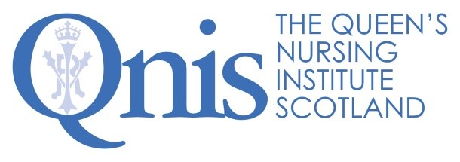
Excellence Profile
Programme Administrator
Healthier Pregnancies, Better Lives

Outputs and productivity |  | - Prioritises work, sifting the important and the urgent, while constantly seeking to do things more effectively.  - Provides seamless administration for this QNIS programme on Preconception Health, Education and Care, as well as Fetal Alcohol Spectrum Disorder (FASD). This includes: maintaining momentum with updates and timely reminders to participants; monitoring progress with accurate record keeping and information management; and, coordinating the day-to-day operations of this programme.  - Brings a successful blend of creativity and meticulous attention to detail to the planning and implementation of the programme’s activities.  - Minimises surprises by thinking ahead, anticipating risks and flagging difficulties and opportunities in advance.  - Provides highly efficient and cheerful support to the coalitions, advisory groups and other committees that co-design and co-produce this programme. For example, this means scheduling meetings to fit with many busy diaries, preparing committee papers, taking Minutes and collating large amounts of complex information into manageable formats.  - Willingness and ability to work productively and independently in a remote setting at least for the duration of the COVID-19 pandemic.
Technical know how | - Great telephone manner, excellent written communications and positive video conferencing presence.  - Well-honed skills in multi-tasking and ability to keep track of work despite interruptions.  - Ability to produce accurate and timely management information, from detailed spread sheets, using an advanced level of knowledge of MS Excel.  - Expert formatting to produce clear and compelling documents in MS Word.  - Skills in project management, using Gantt charts or other tools for detailed scheduling, recording all decisions and milestones to ensure a clear audit trail across the programme’s work.  - Strong ability to use new or bespoke software including CRM, as well as to troubleshoot straightforward IT problems. Familiarity with Office 365 and SharePoint.  - Digital literacy, experience and talent to employ a range of social media platforms appropriately and effectively.
Team work | - Builds and maintains a great rapport with colleagues.  - Demonstrates a ‘can do/will do’ attitude and a willingness to roll up sleeves and deal well with whatever needs is required.  - Understands the challenges and benefits of working in a small team and enjoys doing so.  - Shares knowledge, information and ideas to support working as a team.  - Thrives in a dynamic and rapidly changing environment, embracing change.  - Appreciates the work of the Queen’s Nursing Institute Scotland (QNIS) and the goals of the Healthier Pregnancies, Better Lives programme.  - Has the confidence to ask others for support and also looks for ways to support them.  - Takes time to celebrate after working hard to achieve desired outcomes.  - Brings a sense of fun to the organisation.  - Is open to engaging with staff wellbeing activities befitting QNIS’ status as a Mindful Plus employer.
Relationship management | - Builds positive relationships with everyone involved with QNIS and this programme, in order to enhance our reputation among community nurses, colleagues and participants across Scotland.  - Understands the needs of others and identifies effective ways to meet those needs.  - Able to identify potential pressure points and either defuses, or handles, them well.  - Is trustworthy and continues to build trust through delivering on actions agreed and exceeding the expectations of others.  - Feels comfortable, and is effective, not only when being supervised, but also when working without close supervision.  - Engenders respect within QNIS and its networks.

The Healthier Pregnancies, Better Lives programme is supported by:
