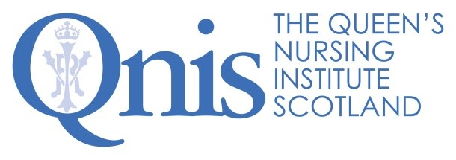
Excellence Profile
Project Coordinator
Healthier Pregnancies, Better Lives

Outputs and productivity |  | - Prioritises work, sifting the important and the urgent, while constantly seeking to do things more effectively.  - Provides seamless administration support for the QNIS programme on Preconception Health, Education and Care, as well as Fetal Alcohol Spectrum Disorder (FASD).  - Enables the Senior Fellow to focus on the strategic by maintaining momentum with updates and timely reminders to participants, monitoring progress with accurate record keeping and information management; and coordinating the day-to-day operations of this programme.  - Brings a successful blend of creativity and meticulous attention to detail to the planning and implementation of the programme’s activities.  - Minimises surprises by thinking ahead, anticipating/managing risks and flagging difficulties and opportunities in advance.  - Provides highly efficient and cheerful support to the Steering Group, coalition members and working groups that co-design and co-produce this programme. This includes establishing and overseeing timelines, scheduling meetings to fit with many busy diaries, preparing committee papers, taking minutes and collating large quantities of complex information into manageable formats.  - Willingness and ability to work productively and independently in a remote setting at least for the duration of the COVID-19 pandemic.
Technical know-how | - Great telephone manner, excellent written communications and positive video conferencing presence.  - Well-honed skills in multi-tasking and ability to keep track of work, despite interruptions.  - Ability to produce accurate and timely management information, from detailed spreadsheets, including an advanced skill level in relation to MS Excel.  - Expert formatting to produce clear and compelling documents in MS Word.  - Skills in project management, using Gantt charts or other tools for detailed scheduling, recording all decisions and milestones to ensure a clear audit trail across the programme’s work.  - Strong ability to use new or bespoke software including CRM, as well as to troubleshoot straightforward IT problems.  - Familiarity with Office 365, MS Teams and SharePoint.  - Digital literacy and ability to work well on social media.
Teamwork | - Builds and maintains a great rapport with colleagues.  - Demonstrates a ‘can do’ attitude and a willingness to roll up sleeves and deal well with whatever is required.  - Understands the challenges and benefits of working in a small team and enjoys doing so.  - Shares knowledge, information and ideas to support working as a team.  - Thrives in a dynamic and rapidly changing environment, embracing change.  - Understands and appreciates the work of the Queen’s Nursing Institute Scotland (QNIS) and the goals of the Healthier Pregnancies, Better Lives programme.  - Has the confidence to ask others for support, while also finding ways to support them.  - Takes time to celebrate after working hard to achieve desired outcomes.  - Brings a sense of fun to the organisation.  - Is open to engaging with staff wellbeing activities befitting QNIS’ status as a Mindful Plus employer.
Relationship management | - Builds and maintains positive relationships with everyone involved with QNIS and this programme, to enhance our reputation among community nurses, colleagues and participants across Scotland.  - Manages ongoing relationships demonstrating agility among stakeholders, whether business contacts, Trustees or members of the international coalition.  - Understands and cares about the needs of others and identifies effective ways to meet those needs.  - Able to identify potential pressure points for the Senior Fellow and either defuses, or handles, them well.  - Is trustworthy and continues to build trust through delivering on actions agreed and exceeding the expectations of others.  - Feels comfortable, and is effective, not only when being supervised, but also when working autonomously without close supervision.  - Engenders respect within QNIS and its networks.

The Healthier Pregnancies, Better Lives programme is supported by:
