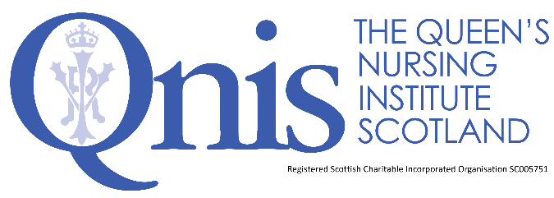

**Application for the Queen’s Nurse Programme 2024**

Guidance for Applicants

***Together, we are building***

***a healthier, fairer, kinder Scotland.***

**Contents**

About QNIS 3

What is a Queen’s Nurse? 4

Why become a Queen’s Nurse? 5

The opportunities and benefits of becoming a Queen’s Nurse 6

The Queen’s Nurse Development Programme 7

Being nominated by your Executive (Nurse) Director 8

Completing the application form 9

The organisational support form 10

Next steps: the assessment and selection process 10

Summary 11

Appendix 1: The framework for person centred practice 12

Appendix 2: The first residential workshop 13

# About QNIS

The Queen’s Nursing Institute Scotland (QNIS) is a charitable organisation (SC005751) which supports, develops, and inspires Scotland’s community nurses and midwives to become agents for health improvement and catalysts for social change. Together, we are building a healthier, fairer, kinder Scotland.

In 2017 The Institute reintroduced the Queen’s Nurse (QN) title to Scotland. You may have met Queen’s Nurses in your area. The nine-month development programme is designed for clinical leaders who can demonstrate their impact as expert practitioners, as community nurses or midwives.

We are building on a long history of Queen’s Nursing in Scotland. Queen Victoria’s Jubilee Institute for Nurses first started training Queen’s Nurses at Castle Terrace in Edinburgh in 1889. Training stopped in 1968 and we have a proud tradition and a clear set of values as a foundation for contemporary community nursing and midwifery excellence.

# What is a Queen’s Nurse?

Queen’s Nurses were the first nationally trained community nurses, and the Institute was set up with a mission to provide nursing care for those most in need the *‘sick poor’*. The training developed over the years and most Queen’s Nurses who trained after WWII were already registered nurses, and midwives, before coming to do their Queen’s training, to develop their skills in district nursing. Many were in ‘triple duty’ roles, serving their communities as district nurse, midwife and health visitor.

Today, we retain our commitment to social justice by providing transformational development opportunities to those committed to addressing inequity in our society in a vast range of community roles. Contemporary Queen’s Nurses currently include general practice nurses, community mental health nurses, school nurses, occupational health nurses, health visitors, community midwives, district nurses, criminal justice nurses, care home nurses and others working in the third sector. 20 candidates are selected each year.

*“The purpose of the Queen’s Nurse programme is to enable nurses who work in Scotland’s communities to be the very best they can be.”*

What does a Queen’s Nurse look like? We have tried to describe this in an

#### ‘Excellence Profile.’

|  |
| --- |
| ***Queen's Nurses Inspiring Others...by making a difference:***  They find opportunities (or circumstances find them) for changing how things are currently done, recognising how things should and could be, making things better for individuals, families and communities and/or helping others to make a significant impact. |
| ***Queen's Nurses Inspiring Others...with tenacity and resilience:***  They find their way across boundaries, around obstacles, through bureaucracy and successfully challenge *“but we don’t have control over that”* or *“that will never work here”* attitudes. They just keep bouncing back, finding new doors to open each time one closes. |
| ***Queen's Nurses Inspiring Others... by bringing people with them:***  Through *“coming from the heart,”* their enthusiasm and persuasive nature, they create a ground swell of support and recognition that has “carried the day”, getting others to commit and get things done. |
| ***Queen's Nurses Inspiring Others...with humility and reflection:***  They listen deeply, seeking to understand what really matters. They approach life reflectively, always learning and are kind to themselves. They will sometimes be surprised by personal recognition for their achievements and are quick to attribute success to the contribution of others. |

# Why become a Queen’s Nurse?

We know that caring for people in their own homes or in a community setting is fundamentally different from working in a hospital. Community practice requires enhanced skills and expertise, and it is important to profile and celebrate this. The Queen’s Nurse title exists to recognise excellent nursing and midwifery practitioners who are committed to social justice. The programme is designed to develop the skills of those who are deeply committed to making a difference in their communities, particularly to the lives of those who live in areas of deprivation or are marginalised by society.

|  |  |
| --- | --- |
| **Our aim is that the Queen’s Nurse title will make a difference at a range of levels. To:** | |
| The Queen’s Nurses themselves | Queen’s Nurses are able to demonstrate exemplary practice as described in the [**Excellence Profile**.](https://www.qnis.org.uk/wp-content/uploads/2023/08/Excellence_Profile_QNDP_2024.docx) Queen’s Nurses are able to join a supported network of others and join a social movement for positive change to the health and wellbeing of Scotland’s communities, addressing inequity. |
| Individuals, families, communities | There is clear evidence of practice and service development because of participants’ involvement in the programme. Individuals, families and communities experience exemplary, high-quality care. |
| Population of Scotland | Queen’s Nurses are seen to be actively involved in improving health and wellbeing and advocating for social justice. |
| Employers | The programme will enable the development of service leaders who inspire others; the recognition of excellence within their areas; and increased profile of high-quality work, from external stakeholders linked to key policy drivers. |
| QNIS | The Institute can fulfil its purpose to promote excellence in community nursing, to enhance the health and wellbeing of the people of Scotland and to enable nurses to be the very best they can be. |
| National policy | By profiling the work of the Queen’s Nurses across community nursing roles, policy makers are enabled to demonstrate and clearly articulate the impact of community nursing roles. |
| The Nursing and Midwifery Professions | The programme will provide role models for excellent community nursing practice, showcasing and inspiring others towards a career in community nursing. |

# The opportunities and benefits of becoming a Queen’s Nurse

* You will have the opportunity to undertake a fully funded, contemporary and inspiring leadership development programme.
* You will become part of an extraordinary network of others, and emerging social movement of changemakers both in your own cohort and those who have been part of the programme before and after you.
* You will embark on a new phase in your career long journey of commitment to addressing inequalities, advocating for social justice in your professional role.
* You will be entitled to use the title ‘Queen’s Nurse’ or the letters QN after your name.
* You will be encouraged to take part in regular ongoing learning opportunities, so you are able to continue to develop and demonstrate your impact as a change maker in your community, with your community.

**The expectations of the Queen’s Nurse**

* You will continue to engage with the Queen’s Nursing Institute Scotland and act as an ambassador for community nursing and midwifery. This may involve having others shadowing you or talking about your work at meetings or events.
* You will keep QNIS up to date with news of your impact, developments and any changes of role or contact details.
* You will actively engage with the growing community of Queen’s Nurses across Scotland. The ambition is to become a social movement of activists for the health and wellbeing of Scotland’s communities, especially the most marginalised.
* You will be profiled in your professional role on the QNIS website and the wider media so that a general audience can see what excellent community nursing and midwifery looks like today and to work with QNIS to update that information periodically.
* You will continue to demonstrate the professional and personal qualities that gained you the title of Queen’s Nurse.
* You will continue to develop your own practice through deep reflection and to act as a role model for others.
* In your role as an ambassador for person-centred approaches to health and care, you will use social media wisely within the guidance set out by the [NMC.](https://www.nmc.org.uk/globalassets/sitedocuments/nmc-publications/social-media-guidance.pdf)
* You will maintain your registration with the NMC and if your registration ceases you will no longer be able to use the Queen’s Nurse title.
* You will renew your QN title each year by completing the annual survey.

# The Queen’s Nurse Development Programme

The programme blends a range of opportunities and learning approaches including three workshops, monthly coaching, peer support and online gatherings.

### Five-day workshop

The first residential takes place soon after the programme begins. This will take place over five days between the 4th and 8th March 2024 (starting Monday lunchtime and finishing after lunch on Friday) at Balbirnie House in Fife. The content of the workshop is underpinned by the Framework for Person Centred Practice (see Appendix 1) and you will be introduced to Theory U. A draft programme for the week can be found in Appendix 2.

### Two further workshops

There are two further workshops, one midway through the programme (online workshop 13th to 14th June 2024), the other towards the end (in person workshop 8th to 10th October 2024).

### Individual coaching and support

Each candidate will be supported by individual coaching. Following an initial face to face meeting with the coach at the five-day workshop, the coaching sessions are 45 minutes monthly by telephone. Additional support will be provided by the virtual community of Queen's Nurses, through a Queen’s Nurses Teams site and a cohort WhatsApp group. In addition, there will be opportunities to gather on Zoom.

### Co-production (an issue for development)

During the programme every candidate will be expected to work on an issue for development which makes a difference to their community, based on a need which they have identified with their sponsor (who may be a senior nurse or other senior manager in the organisation). The work is to be co-produced with those affected, so your plans will emerge in partnership with others. There is an expectation that this has a focus on promoting equity and inclusion. It is expected that the issue is taken forward as an integral part of your core role in negotiation with your sponsor. However, to make the most of the opportunity some candidates have found it helpful to negotiate some additional development time to take the issue forward. It may be helpful to protect some additional time to enable you to explore the literature or contact others in the area under review or to set up meetings with stakeholders and listen to their ideas. This needs to be carefully discussed with your sponsor from the outset, so expectations are managed.

### Costs

In partnership with several external sponsors, the Queen’s Nursing Institute Scotland funds the development programme: the five day (Monday-Friday) residential workshop, the two other workshops, individual coaching as well as all accommodation. We have a budget to cover travel costs for those who are coming from remote and rural areas and those in financial hardship. If those living more centrally are willing to see their travel costs as their commitment to the programme, it enables us to focus the charity’s resources on other areas of need. To demonstrate their commitment to supporting your development though the programme we ask employers to fund the time for candidates to participate.

# Being nominated by your Executive (Nurse) Director

### Given that there are currently only twenty places each year, we are working with the Executive Nurse Directors in NHS Scotland and equivalent executive leaders from the third and independent sector to nominate candidates who they are committed to supporting. Those nominated will then apply using a written application to demonstrate their skills against the Excellence Profile and describe an issue which they would like to explore during the development programme.

Executive Nurse Directors (for third and independent sectors, the most senior member of your organisation) have been asked to work with their senior team to identify candidates to put forward for selection. The most important quality is that those selected should be enthusiastic about being put forward to be Queen’s Nurses and committed to making a difference for their community. We are looking to profile the work of clinical experts across the length and breadth of community midwifery, clinical nursing and public health specialities, who have a real commitment to addressing health inequalities. Given that Queen’s Nurses are role models, we are particularly keen to encourage nominations from those in black and minority ethnic groups who are currently under-represented. We are also committed to developing younger nurse leaders.

Candidates being nominated as potential Queen’s Nurse candidates should meet the following criteria. You must:

* Be open to creative, contemplative and compassionate ways of developing your awareness as a professional.
* Be committed to activism for social justice in your area of practice.
* Have current registration with the NMC as a nurse, or midwife.
* Spend the majority of your professional time in the community.
* Be known as a clinical expert and seen as a role model by your peers.
* Demonstrate the qualities outlined in the [Excellence Profile.](https://www.qnis.org.uk/wp-content/uploads/2023/08/Excellence_Profile_QNDP_2024.docx)
* Be available to attend a selection event (see below).
* Be available to attend all three workshops (dates above).
* Have the full support of a manager as sponsor within your organisation.
* Have a development issue in mind, agreed with their sponsor to work on during the Queen’s Nurse Development Programme.
* Have a signed commitment of support from the Executive Nurse Director

or equivalent.

# Completing the application form

This is an opportunity for you to take your personal and professional development to a new, exciting level and be recognised as a role model in your area. Once you have been nominated by your Executive Nurse Director (or equivalent executive leader for third sector or independent employers) you will need to complete the application form. Since the opportunity is an important one, we are asking people to be reflective in their applications. This is similar to the reflective accounts which you develop for NMC revalidation. It will take considerable time and thought to complete the application and we recommend that you allow yourself a few weeks to complete the various sections and check them over. Please allow time for a “critical companion” to review your application before you submit it. There are examples of completed applications on the website, which you might find useful. They are actual applications and we have not been able to fully disguise the identities of those who wrote them. Please treat the information with sensitivity.

The first sections of the application require information about your career and current role. The supporting information, section 2, asks that you reflect on your practice in the light of the [**Excellence Profile**](https://www.qnis.org.uk/wp-content/uploads/2023/08/Excellence_Profile_QNDP_2024.docx) which you will have seen on page 4. The Excellence Profile describes the contemporary Queen’s Nurse and the qualities which we will be looking to develop further over the course of the development programme. We are looking for examples from your practice of ***how*** your expertise already matches the areas described in the profile, recognising that this is a development journey.

Please remember this is not a job application, we are not looking for a list of your achievements, we are however looking to hear your voice and self-awareness; your ability to reflect on how your role and behaviours have had an impact on patients and colleagues. We understand that it feels uncomfortable to ‘blow your own trumpet’ but the application asks you to identify your strengths and challenges and to share the feedback you have had from others and what you have learned about yourself as you have developed over your career.

Section 3 asks you to describe your vision for the role of contemporary Queen’s Nurses in Scotland’s communities and why you would like to be selected. In your own words, please describe what this opportunity means to you and why you would like to be considered. Do you have a vision of what *the best you can be* looks like and the change you would like to bring to the people you work with?

We ask that you write between 350-500 words when completing your answers for sections 2 and 3. Section 4 asks you to outline your issue for development.

Your issue for development is something that you would like to work on with the support of your coach during the nine-month programme. In your answer please include:

* + the nature of the issue, inequality or community need you wish to address.
  + who will need to be involved?
  + how you hope to engage those affected, and
  + what you hope might be achieved.

For example, you may have identified that there are significant health issues caused by obesity in a particular neighbourhood. You may decide that you would like to work with local third sector organisations, and voluntary groups, general practice team members and the local school to fully explore what already exists and how best to connect people in new ways to activate a more healthful community.

|  |
| --- |
| **Please send your completed application forms along with your signed organisational support form to:** [**qndp@qnis.org.uk**](mailto:qndp@qnis.org.uk) **no later than midday, Monday 15th November 2023.** |

# The organisational support form

This additional form is to be completed by your manager who agrees to act as sponsor during your development programme. This is likely to be a senior nurse who has line management responsibility for your team. You may not be managed by a senior nurse, and you may prefer to work with another senior member of staff as your sponsor.

Your sponsor will work with you on your development issue, agreeing the work as a priority for your organisation and community, and supporting you as you scope and develop the initiative.

This form needs to be counter signed by your Executive Nurse Director in NHS Boards, a GP Partner or an equivalent executive leader.

# Next steps: the assessment and selection process

Once you have submitted your application, it will be assessed by a panel who will meet in November to decide a shortlist of candidates. Invitations to a selection day for those who are on the shortlist will be sent week commencing 4th December 2023.

The selection days have been carefully designed to be relaxed, informal and interactive. From your written application forms we will have robust information about your experience, expertise and your proposed project, so the focus of the selection days will be on meeting you and hearing your story. Please ensure that you are available on the day allocated to you. If you are not available, please let us know and we will do our utmost to accommodate you on another date.

|  |  |  |
| --- | --- | --- |
| **Date** | **Time** | **Location** |
| Friday 12th January 2024 | 1000-1600 | The Quaker Meeting House, 7 Victoria Terrace, Edinburgh, EH1 2JL |
| Tuesday 16th January 2024 | 1000-1600 | The Erskine Park Home, Bishopston, PA7 5QA |

We hope that whatever the outcome, you will enjoy the process of applying and that even if you are not selected that the process of reflection in completing the application will have been affirming and useful. Please be aware that as well as personal qualities, we are looking to develop a range of expert practitioners from across the regions of Scotland in line with the priorities stated above, so if you are not selected it may not be just about merit, but a range of other factors. Please do not be discouraged, but continue your path as a role model, staying connected with QNIS.

All candidates will be given written feedback from the application and assessment process which can be used for appraisal and revalidation.

# Summary

#### Please ensure that you have been put forward (nominated) by your employer BEFORE starting to complete the application form.

#### Please answer each question on the application form clearly and completely. Full answers are required to enable the panel to assess whether you have the qualities to be a new Queen’s Nurse.

#### Please ensure that you include an organisational support form with your application which needs to be completed by your sponsor and countersigned at executive level.

#### Applications received after the closing date of 15th November 2023 at midday, will not be considered.

It is required that you are available on all the following dates:

* Selection events 12th or 16th January 2024
* Residential workshop from 4th- 8th March 2024.
* Follow up workshops 13th-14th June 2024 and 8th - 10th October 2024.

Please get in touch if you have any further questions.

Tel: 0131 229 2333

Email: qndp@qnis.org.uk

## “This is a great opportunity to unleash your potential, and to join a movement of nurses committed to making a lasting difference in Scotland’s communities.”

*Clare Cable, QNIS Chief Executive and Nurse Director*

# Appendix 1: The framework for person centred practice

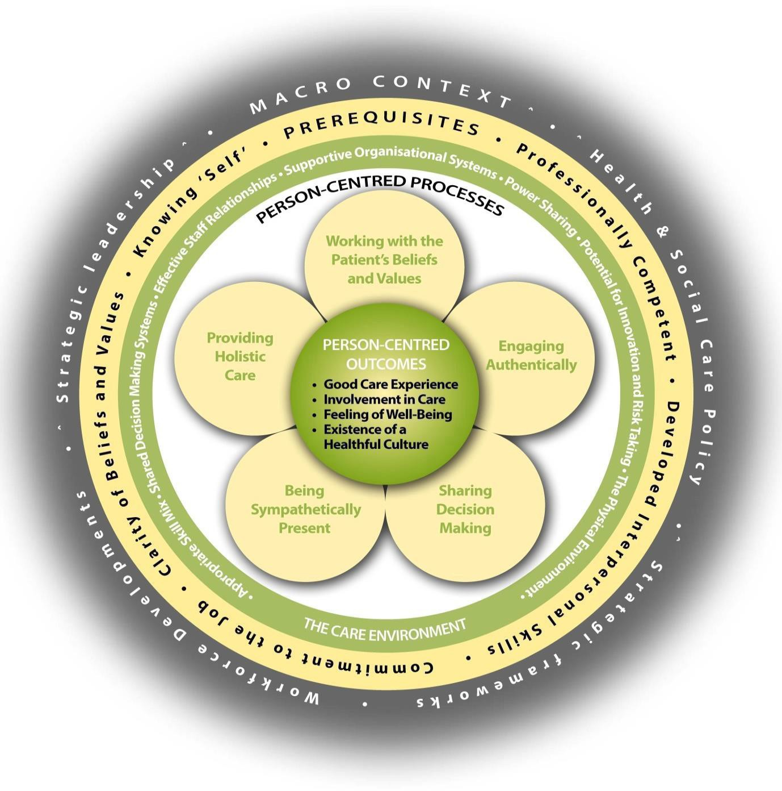

Brendan McCormack, Tanya McCance (2016), Person-centred Nursing: Theory and Practice, Wiley-Blackwell

# Appendix 2: The first residential workshop

#### A five-day *journey of discovery* – outline programme

|  |  |  |  |
| --- | --- | --- | --- |
|  | **Excellence profile** | **Theme** | **Master class content** |
| ***Monday*** | *Queens Nurses…. Inspiring Others with humility and reflection* | Reflecting | Personal values  Critical reflection |
| ***Tuesday*** | *Queens Nurses…. Inspiring Others with tenacity and resilience* | Enabling | Self as a leader  Personal resilience  Theory U |
| ***Wednesday*** | *Queens Nurses…. Inspiring Others by making a difference* | Presencing | Person-centred culture  Making change happen  Engagement and belonging |
| ***Thursday*** | *Queens Nurses…. Inspiring Others by bringing people with them* | Partnering | Momentum for change  Listening and observing  Creating connections  Building networks |
| ***Friday*** | *Overview* | Reflecting  Enabling  Presencing  Partnering | Participatory evaluation  Planning the journey,  Reflecting on the learning from the week. |